14TH MEETING OF THE SPRFMO COMMISSION
Panama City, Panama, 2 to 6 March 2026

COMM 14 – Prop 07
Proposal to:
☒ Amend  ☐ Create | CMM 03-2025 Bottom Fishing
Submitted by: New Zealand
Summary and objectives of the proposal:

Introduction

Article 2 of the SPRFMO Convention includes the objective of ensuring the long-term sustainable use of fishery resources. If management measures become too restrictive, then achieving that objective can be challenging.

2019 saw significant changes to CMM03 with the introduction of CMM03-2019 and subsequent iterations of the measure. Since 2018/2019 bottom and midwater trawling activity and catch under this CMM have declined significantly, although the COVID-19 pandemic created additional challenges during this period.

New Zealand’s annual report to the SC in 2025 details the decline of orange roughy effort and catch in figure 3 of that report below:

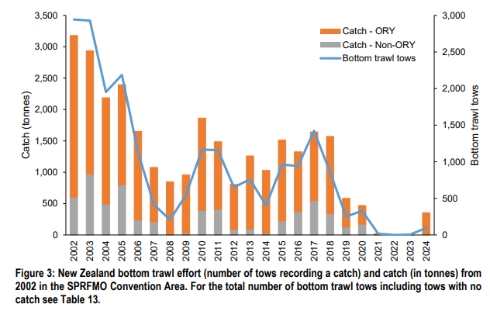

Australian flagged vessels have not bottom trawled since 2019.

The 2nd Performance Review, which was presented at the 2025 Commission meeting, included consideration of the bottom fishing measure. The panel noted that:

“The current measure is difficult to regulate, costly to maintain from a scientific perspective, and may have hindered the industry beyond what is biologically necessary. The Review Panel does not suggest discarding SPRFMO’s previous efforts but recommends that the Commission explore a range of management options to meet the objectives of the Convention. If it is found that the industry cannot operate effectively within the Convention’s objectives, this should be determined after exploring alternatives, not based on one management regime alone.”

In the short term, New Zealand wants to ensure that fishing activities remain economically viable. This can be supported by amendments to the move on rule thresholds. For the longer term, New Zealand is currently undertaking work on bioregionalization through the Scientific Committee, with the aim that it will help inform fisheries management through the spatial protection framework.

Proposed amendments – move on rule thresholds

New Zealand developed candidate encounter thresholds that were presented to the 2021 SC in SC9-DW10 - See table 3 of that paper below.

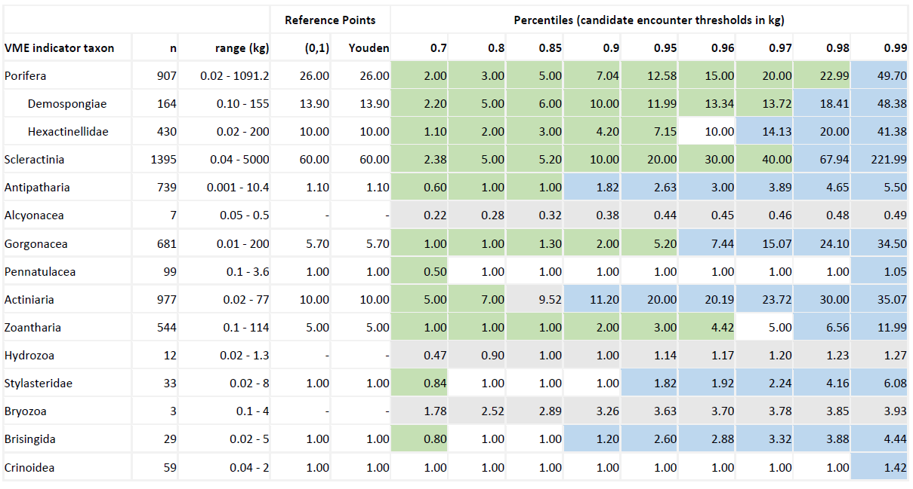

The SC9 “recommended to the Commission that the updated candidate encounter thresholds for VME indicator taxa presented in SC9-DW10 are used to inform any future refinement of the VME indicator taxa thresholds included in annex 6A and 6B of SPRFMO CMM 03-2021”. The SC did not specify which thresholds should be selected, with that choice being made by the Commission.

Some of these thresholds contained in annexes 6A and 6B are proposed for increase in line with scientific advice provided for in SC9-DW10 – see proposed changes in the tables below. SPRFMO remains the only RFMO with a biodiversity threshold and would still have arguably the most restrictive move on rule settings of any RFMO. Given the relatively low levels of catch allocation (approx. 1,000 tonnes total for all areas) and fishing activity (1-2 vessels catching a few hundreds tonnes), the current risks to VMEs are low overall, relative to a situation where there is a much higher catch allocation and fishing activity. The benefit of raising the thresholds is to potentially reduce the compliance burden and uncertainty for industry.

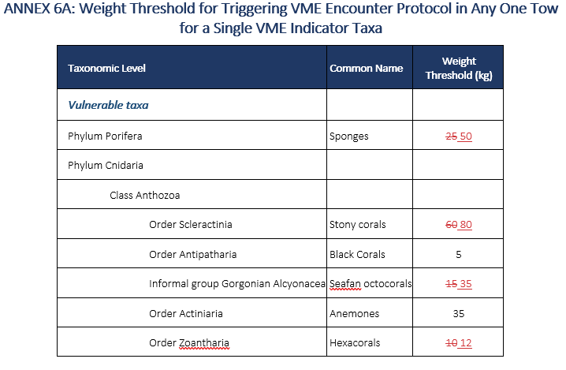

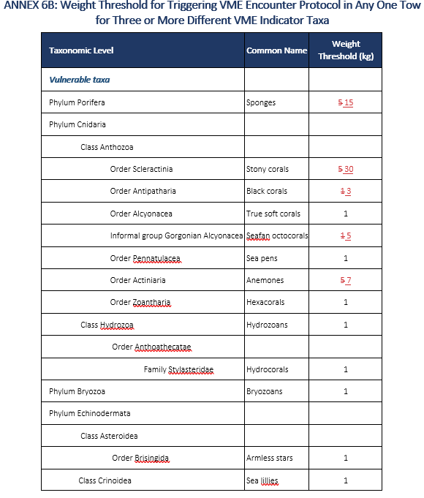

Has the proposal financial impacts or influence on the Secretariat work? |  |  | ☐ Yes  ☒ No
Ref: COMM14-PROP07 |  | Received on: 9 January 2026

CMM 03-2026

Conservation and Management Measure for the Management of Bottom Fishing in the SPRFMO Convention Area
(Supersedes CMM 03-2025)

The Commission of the South Pacific Regional Fisheries Management Organisation;
RECOGNISING Article 2 of the Convention on the Conservation and Management of High Seas Fishery Resources in the South Pacific Ocean (the Convention), which provides that the objective of the Convention is, through the application of the precautionary approach and an ecosystem approach to fisheries management, to ensure the long-term conservation and sustainable use of fishery resources and, in so doing, to safeguard the marine ecosystems in which these resources occur;
FURTHER RECOGNISING Articles 3(1)(a)(i) and (vii) of the Convention, which call on the Commission, in giving effect to the objective of the Convention, to adopt Conservation and Management Measures (CMMs) that take account of international best practices and protect marine ecosystems, particularly ecosystems with long recovery times following disturbance;
FURTHER RECOGNISING Articles 3(1)(b) and (2) of the Convention which call on the Commission to apply the precautionary approach and an ecosystem approach to the conservation and management of fishery resources under the mandate of the Convention;
FURTHER RECOGNISING Article 4 of the Convention in which Contracting Parties acknowledge their duty to cooperate to ensure compatibility of CMMs established for fishery resources that are identified as straddling areas under national jurisdiction and the adjacent high seas of the Convention Area;
MINDFUL of Article 31(1) of the Convention which calls on the Commission to cooperate with other regional fisheries management organisations (RFMOs), the Food and Agriculture Organization of the United Nations (FAO), other specialised agencies of the United Nations and other relevant organisations on issues of mutual interest;
RECALLING that in 2007, Participants in the International Consultations on the Establishment of the South Pacific RFMO adopted voluntary interim management measures, including inter alia, for the management of bottom fisheries in the Convention Area;
NOTING United Nations General Assembly (UNGA) Resolution 61/105 which calls upon RFMOs to assess, on the basis of the best available scientific information, whether individual bottom fishing activities would have significant adverse impacts on vulnerable marine ecosystems (VMEs), and to ensure that if it is assessed that these activities would have significant adverse impacts, they are managed to prevent such impacts, or not authorised to proceed;
FURTHER NOTING UNGA Resolution 64/72 which calls upon RFMOs to establish and implement appropriate protocols for the implementation of UNGA Resolution 61/105, including definitions of what constitutes evidence of an encounter with a VME, in particular threshold levels and indicator species; and to implement the FAO International Guidelines for the Management of Deep-sea Fisheries in the High Seas (FAO, 2009; FAO Deep-sea Fisheries Guidelines) in order to sustainably manage fish stocks and protect VMEs;
FURTHER NOTING UNGA Resolution 66/68 which encourages RFMOs to consider the results available from marine scientific research, including those obtained from seabed mapping programmes concerning the identification of areas containing VMEs, and to adopt CMMs to prevent significant adverse impacts from bottom fishing on such ecosystems, consistent with the FAO Deep-sea Fisheries Guidelines, or to close such areas to bottom fishing until such CMMs are adopted, as well as to continue to undertake further marine scientific research, in accordance with international law as reflected in Part XIII of the 1982 Convention;
FURTHER NOTING UNGA Resolutions 71/123 and 72/72 which call upon RFMOs to use the full set of criteria in the FAO Deep-sea Fisheries Guidelines to identify where VMEs occur or are likely to occur as well as for assessing significant adverse impacts, to ensure that impact assessments, including for cumulative impacts of activities covered by the assessment, are conducted consistent with the FAO Deep-sea Fisheries Guidelines, are reviewed periodically and are revised whenever a substantial change in the fishery has occurred or there is relevant new information, and that, where such impact assessments have not been undertaken, they are carried out as a priority before authorising bottom fishing activities, and to ensure that CMMs are based on and updated on the basis of the best available scientific information, noting in particular the need to improve effective implementation of thresholds and move-on rules;
FURTHER NOTING UNGA Resolution 77/118 which calls on States and RFMOs to identify and overcome barriers in the implementation of earlier Resolutions such as data availability, especially with regard to baseline data and the spatial distribution and connectivity of vulnerable marine ecosystems, including their associated and dependent species, while recognising the importance of international collaboration for this purpose; and recognising that effective management of bottom fisheries is crucial to ensure the long-term sustainability of the sector;
MINDFUL that the Report of the Bottom Fishing Intersessional Working Group contained in COMM11-Doc07 provides a comprehensive review of this conservation and management measure and the technical work, and that SPRFMO is using best available science;
ENCOURAGED that the Scientific Committee’s Multi-Annual Work Plan will contribute to improving the Commission’s understanding of vulnerable marine ecosystems within the SPRFMO Convention Area;
DETERMINED to ensure that the precautionary approach is applied, including in the utilization of impact assessments to inform management decisions and consideration of significant adverse impacts on vulnerable marine ecosystems, including their associated and dependent species, consistently with the actions called for by UNGA Resolution 77/118;
RECOGNISING the immense importance and value of deep-sea ecosystems and the biodiversity they contain, as documented in the first World Ocean Assessment;
BEARING IN MIND the FAO Deep-sea Fisheries Guidelines are recommended international minimum standards to be taken into account, and that the Guidelines describe what constitutes significant adverse impacts, factors to be considered when determining the scale and significance of an impact, what constitutes temporary impacts and factors to be considered in determining whether an impact is temporary;
REAFFIRMING the steps already taken by the Commission to address the impacts of large‐scale pelagic driftnets and all deepwater gillnets in the Convention Area, through the implementation of CMM 08-2023 (Gillnetting);
RECOGNISING Articles 20(1)(a) and (d) of the Convention, which provide that the CMMs adopted by the Commission shall include measures to ensure the long-term sustainability of fishery resources and promote the objective of their responsible utilisation, and to protect the habitats and marine ecosystems in which fishery resources and non-target and associated or dependent species occur from the impacts of fishing, including measures to prevent significant adverse impacts on VMEs and precautionary measures where it cannot adequately be determined whether VMEs are present or whether fishing would cause significant adverse impacts on VMEs;
FURTHER RECOGNISING Article 22 of the Convention, which provides that a fishery that has not been subject to fishing or has not been subject to fishing with a particular gear type or technique for ten years or more shall be opened only when the Commission has adopted cautious preliminary CMMs in respect of that fishery, and, as appropriate, non-target and associated or dependent species, and appropriate measures to protect the marine ecosystem in which that fishery occurs from adverse impacts of fishing activities;
ADOPTS the following CMM in accordance with Articles 8, 20, 21 and 22 of the Convention:

Objective
- The objective of the CMM together with CMM 03a-2025 (Deepwater Species) is, through the application of the precautionary approach and an ecosystem approach to fisheries management, to ensure the long-term conservation and sustainable use of deep sea fishery resources, including target fish stocks as well as non-target or associated and dependent species, and, in doing so, to safeguard the marine ecosystems in which these resources occur, including inter alia the prevention of significant adverse impacts on vulnerable marine ecosystems.

Definitions
- For the purposes of this CMM, the term “bottom fishing” is defined as fishing using any gear type likely to come in contact with the seafloor or benthic organisms during the normal course of operations, and includes inter alia:
  - “Bottom trawl” which is defined as fishing using a trawl net that is designed to be pulled through the water and to come into contact with the seabed;
  - “Mid-water trawl” which is defined as fishing for bentho-pelagic species using a trawl net that is designed to be pulled through the water near the seabed and designed not to come into extended contact with the seabed;
  - “Bottom line” which is defined as fishing using a line to which a hook or hooks (whether baited or not) are attached and rigged to sink and fish on or near the seabed. This includes, but is not limited to, longlines, hand lines, drop lines, trot lines, and dahn lines.
- For the purposes of this CMM, the term “vulnerable marine ecosystem” (VME) means a marine ecosystem that has the characteristics referred to in paragraph 42 of, and elaborated in the Annex to, the FAO Deep-sea Fisheries Guidelines.
- For the purposes of this CMM, the term “Evaluated Area” means those parts of the Convention Area that are within the area starting at a point of 24°S latitude and 146°W, extending southward to latitude 57° 30S, then westward to 150°E longitude, northward to 55°S, westward to 143°E, northward to 24°S and eastward back to point of origin (Annex 1).
- For the purposes of this CMM, the term “Management Area(s)” means those parts of the Evaluated Area specified in paragraph 14.
- For the purposes of this CMM, the term “fishing year” means the period starting 0001 hours UTC on 1 January and ending 2359 hours on 31 December in the same year.
- For the purposes of this CMM, ‘Fishery Management Area’ has the same meaning as in CMM 03a-2025.

General Provisions
- This CMM applies to the entire Convention Area.
- This CMM together with CMM 03a-2025 (Deepwater Species) are adopted as cautious preliminary CMMs consistent with Article 22(1) of the Convention.
- This CMM together with CMM 03a-2025 (Deepwater Species) applies to all fishing vessels flying the flag of a Member or Cooperating non-Contracting Party (CNCP) to the South Pacific Regional Fisheries Management Organisation (SPRFMO) engaging or intending to engage in bottom fishing in the Convention Area.
- Members and CNCPs shall prohibit vessels flying their flag from participating in bottom fishing in the Convention Area other than in accordance with the provisions of this CMM together with CMM 03a-2025 (Deepwater Species).
- Only fishing vessels duly authorised pursuant to Article 25 of the Convention and in accordance with CMM 05-2023 (Record of Vessels) that are flagged to Members and CNCPs shall participate in bottom fishing in the Convention Area.
- No Member or CNCP shall authorise vessels flying their flag to engage in any bottom fishing in the Convention Area unless:
  - Authorisation has been given by the Commission under paragraph 22(d)(i); or
  - approval has been given by the Commission under paragraph 14 of CMM 13-2024 (Exploratory Fisheries).

Bottom Fishing Management Areas
- The Commission hereby establishes within the Evaluated Area the following Management Areas, the coordinates for which are provided in Annex 4:
  - Bottom trawl Management Area
  - Mid-water trawl Management Area
  - Bottom line Management Area
- Bottom fishing in the Convention Area shall occur only in the three Management Areas established in paragraph 14 and in accordance with the terms of this CMM together with CMM 03a-2025 (Deepwater Species). CMM 13-2024 (Exploratory Fisheries) does not apply to bottom fishing in the three Management Areas established in paragraph 14.
- Notwithstanding paragraphs 11 and 15, proposals to undertake bottom fishing:
  - outside a Management Area; or
  - inside a Management Area using bottom fishing methods other than bottom trawl, midwater trawl or bottom line fishing; or
  - in a mid-water trawl Management Area using bottom trawl gear or in a bottom line Management Area using bottom trawl or mid-water trawl gear; or
  - inside a Management Area targeting species not previously targeted in the area proposed to be fished (unless the species has regularly been caught as part of an existing fishery);
shall be handled in accordance with CMM 13-2024 (Exploratory Fisheries).
- Unless a Member or CNCP is fishing in an exploratory fishery established pursuant to CMM 13-2024 (Exploratory Fisheries), Members and CNCPs shall ensure that vessels flying their flag comply with the following provisions:
  - Bottom trawling shall only occur in a bottom trawl Management Area;
  - Midwater trawling shall only occur in a midwater trawl Management Area or a bottom trawl Management Area;
  - Bottom lining shall only occur in a Management Area.
- The Commission may in future establish, disestablish, or adjust the boundaries of the Evaluated Area or any Management Area, based on advice from the Scientific Committee.
- From 2024, the Commission shall apply a minimum of 70% protection of suitable habitat for each modelled VME indicator taxa. The Commission, taking into account the advice and recommendations of the Scientific Committee, shall review the boundaries of the Management Areas established in paragraph 14 and Annex 4 of this CMM and make any modifications necessary to achieve this level of protection at its 12th annual meeting in 2024.

Marine Mammals, Seabirds, Reptiles and Other Species of Concern
- Members and CNCPs shall require vessels flying their flag and undertaking bottom fishing to implement seabird mitigation measures in accordance with CMM 09-2017 (Seabirds), and shall report annually to the Commission on bycatch rates and total bycatch estimates in accordance with CMM 02-2025 (Data Standards) and the Guidelines for Annual National Reports to the SPRFMO Scientific Committee.
- The Scientific Committee shall provide advice biennially to the Commission on:
  - direct and indirect interactions between bottom fishing and marine mammals, seabirds, reptiles and other species of concern;
  - any recommended spatial or temporal closures or spatially/temporally limited gear prohibitions for any identified hotspots of these species; and
  - any recommended bycatch limits and/or measures for an encounter protocol for any of these species.

Assessment of Proposed Bottom Fishing
- Subject to paragraph 16, all proposals to undertake bottom fishing in one of the Management Areas established in paragraph 14 shall be subject to an assessment process, based on the best available scientific information and taking into account the history of bottom fishing in the areas proposed and cumulative impacts of past and proposed fishing. The assessment will determine if such fishing would contribute to having significant adverse impacts on VMEs, and to ensure that if it is determined that this fishing would make such contributions, that they are managed to prevent such impacts or not authorised to proceed. The assessments shall follow the following procedures:
  - Each Member or CNCP proposing to participate in bottom fishing activities shall submit to the Scientific Committee a proposed assessment that meets the SPRFMO Bottom Fishery Impact Assessment Standard (SPRFMO BFIAS) with the best available data including consideration of cumulative impacts, not less than 60 days prior to the annual meeting of the Scientific Committee. BFIAs shall be prepared using a scale no coarser than the Fishery Management Area. These submissions shall also include the mitigation measures proposed by the Member or CNCP to prevent such impacts.
  - The Scientific Committee shall undertake a review of the proposed assessment and provide advice to the Commission on:
- whether the proposed bottom fishing would contribute to having significant adverse impacts on deep sea fish stocks for which no stock assessment has been completed, bycatch species and/or VMEs and, if so,
- whether any proposed or additional mitigation measures would prevent such impacts.
  - In its review of the proposed assessment, the Scientific Committee may use additional information available to it, including information from other fisheries in the region or similar fisheries elsewhere. The Scientific Committee is not obliged to consider, or provide advice on, proposed assessments provided after the deadline for submission of proposed assessments contained in paragraph 22(a).
  - On the basis of the Scientific Committee’s review of the submitted assessment, taking into account any recommendations and advice of the Scientific Committee and in line with the precautionary approach, the Commission shall consider:
    - whether, and if applicable the extent to which, bottom fishing in the Management Area(s) for which the proposed assessment was conducted should be authorised;
    - which, if any, additional measures (which may include closures) to those proposed are required pursuant to Article 20 to prevent significant adverse impacts on VMEs;
    - which, if any, additional precautionary measures are required where it cannot adequately be determined whether VMEs are present or whether fishing could cause significant adverse impacts on VMEs;
    - data availability, especially with regard to baseline data and the spatial distribution and connectivity of vulnerable marine ecosystems, including their associated and dependent species; and
    - in relation to an application to target a species for which no total catch limit exists, an exemption for such a Member or CNCP to paragraph 11 of CMM 03a-2025 (Deepwater Species), bearing in mind the need to be precautionary.
- Members and CNCPs whose bottom fishing proposal has been authorised by the Commission under paragraph 22(d)(i) shall ensure that a proposed assessment meeting the requirements contained in paragraph 22(a) is submitted to the Scientific Committee and Commission at least every 3 years, and also when a substantial change in the fishery has occurred such that it is likely that the risk or impact of the fishery may have changed.
- The Secretariat shall make publicly available on the SPRFMO website all assessments submitted in accordance with paragraph 21(a) within three days of receipt and shall invite public comment for 30 days from the date of publication on such assessment. The Secretariat shall also make the Scientific Committee’s review of such assessments public in accordance with its usual procedures,
- The Scientific Committee shall review, and update if required, the SPRFMO BFIAS every 5 years, starting in 2025, to ensure that it reflects, as appropriate, best practice.

Encounters with Potential VMEs
- For the purposes of this section of the CMM, the term “VME indicator taxa” means any benthic organism listed in Annex 5.
- For the purposes of this section of the CMM, the term “Encounter” means catch of a VME indicator taxa at or above threshold levels as set out in paragraph 28.
- Where VME indicator taxa are encountered in any one tow at or above the weight threshold in Annex 6A, or three or more different VME indicator taxa at or above the weight thresholds in Annex 6B, Members and CNCPs shall require any vessel flying their flag to:
  - cease bottom fishing immediately within an encounter area of one (1) nautical mile either side of the trawl track extended by one (1) nautical mile at each end;
  - report the encounter immediately to the Member or CNCP whose flag the vessel is flying and the Secretariat, in accordance with the Guidelines for the preparation and submission of notifications of encounters with potential VMEs, contained in Annex 7.
- In the event of an encounter, Members and CNCPs shall cooperate to the extent possible with the Secretariat and other Members or CNCPs engaged in bottom fishing to exchange such data and information as may be relevant to the Scientific Committee’s consideration of the encounter area.
- On receipt of a notification under paragraph 28(b) the Secretariat shall:
  - record the location of the encounter area;
  - within three (3) working days of receipt, notify all Members and CNCPs that bottom fishing is suspended in the encounter area in paragraph 28(a); and
  - publicise the encounter area on the internal part of the SPRFMO website for the duration of the suspension.
- Members and CNCPs shall ensure that vessels flying their flags do not bottom fish in an encounter area notified under paragraph 30(b) unless and until such time as the Commission determines management actions under paragraph 34 that would permit the resumption of bottom fishing in the area.
- Members and CNCPs shall submit to the Scientific Committee a review of each encounter by vessels flying their flag that resulted in a temporary suspension pursuant to paragraph 28, which meets the SPRFMO Encounter Review Standard (SPRFMO ERS). Each review must include a detailed description of each encounter, an assessment of whether a VME is known or likely to occur within the encounter area, an evaluation to assess if re-opening the encounter area will expose any VMEs to significant adverse impacts, and suggested management actions to prevent significant adverse impacts on VMEs. Members and CNCPs should provide as much detail as possible to verify whether a VME is likely to be present at the encounter area and/or the surrounding area, whether a significant adverse impact has occurred, and the risk of a significant adverse impact occurring in the future.
- The Scientific Committee, at its next annual meeting, and in accordance with the requirements of the SPRFMO ERS, shall review all encounters reported pursuant to paragraph 28(b) once the relevant Member or CNCP has provided its review pursuant to paragraph 32, and provide advice on management actions proposed by the relevant Member or CNCP under paragraph 32 and any alternate or additional management actions the Scientific Committee considers appropriate. The Scientific Committee shall:
  - Apply the Convention, including Article 3(2)(a);
  - Consider the detailed analyses provided by a Member or CNCP pursuant to paragraph 32 including:
- historical fishing events within 5nm of the encounter tow, in particular, any previous encounters, and all information on benthic bycatch;
- model predictions for all VME indicator taxa and associated uncertainty layers, including predictions discounted for historical fishing impacts;
- details of the relevant fishing activity, including the bioregion in which the encounter occurred (noting that different regions have different compositions of benthic bycatch, for example stony coral are more commonly caught on the Louisville Ridge than elsewhere); and
- any other information the Scientific Committee considers relevant. This could include spatial scales of endemicity for the taxa impacted, spatial scales of connectivity and meta-population dynamics, catchability of VME indicator taxa, and taxonomic resolution of the bycatch records in relation to species complexes;
  - Apply the FAO Deep-sea Fisheries Guidelines, including to use the full set of criteria contained therein to identify where VMEs occur or are likely to occur, as well as for assessing significant adverse impacts on such ecosystems, including their associated and dependent species;
  - In its review, the Scientific Committee must provide a clear determination regarding the adequacy of information included in the Member’s or CNCP’s review pursuant to paragraph 32, including the robustness of the analyses, to:
- determine if a VME is known or likely to occur within the encounter area;
- determine if reopening the encounter area will expose any VMEs to significant adverse impacts;
- provide meaningful advice and recommendations, with the objective of avoiding significant adverse impacts on VMEs;
- Notwithstanding paragraph 33, the Scientific Committee may defer consideration of an encounter if:
  - there is inadequate information to provide meaningful advice and recommendations; or
  - The relevant Member of CNCP has notified the Scientific Committee of a delay pursuant to paragraph 32; or
  - There has been insufficient time for the flag State to present the relevant information within the normal timeframes for the submission of working papers to the Scientific Committee.
- At its next annual meeting, the Commission shall determine, for each encounter, management actions to prevent significant adverse impacts on VMEs, which may include: the closing of some areas to some or all bottom fishing gear, temporal restrictions, spatial restriction, reopening areas. Management actions determined by the Commission will apply as appropriate, unless otherwise determined, from the conclusion of the relevant Commission meeting. The Commission shall base its decision on the Scientific Committee’s advice; and be satisfied that its decision is consistent with the requirements of the Convention, including Article 3(2)(a).
- For the avoidance of doubt, each VME encounter shall be assessed against the requirements of the relevant CMM in effect at the time of the encounter. However, this shall not preclude the Scientific Committee and/or the Commission from taking into account the best available science in relation to the encounter in discharging their respective functions within the encounter review process.
- The Scientific Committee shall review, and update if required, the SPRFMO ERS every 5 years, starting in 2029, to ensure that it reflects best practice.
- The Scientific Committee shall, in addition to the 5 yearly reviews, update the SPRFMO ERS as needed to account for the best available scientific information relevant to determining the presence of VMEs or to assessing adverse impacts on VMEs;

General Provisions Regarding the Scientific Review of Information
- Members and CNCPs shall submit to the Secretariat annual reports of all benthic bycatch data from vessels flying their flag, consistent with CMM 02-2025 (Data Standards), as part of their annual reports to the Scientific Committee, to enable an ongoing review of the effectiveness of the spatial management arrangements.
- The Scientific Committee shall review all available data and provide advice on the ongoing effectiveness of the management measures in this CMM to ensure the measure meets its objective and the objectives of the Convention and implements the relevant United Nations General Assembly Resolutions.
- From 2023, the Scientific Committee shall adopt the Fishery Management Area as the appropriate scale of management for assessing the performance of the VME spatial management scenarios that underpin this CMM.
- The Scientific Committee shall develop a biologically-relevant multi spatial-scale risk-based approach to assess encounters with VME indicator taxa. The Scientific Committee shall take into account the Convention and the FAO DeepSea Fisheries Guidelines and may consider a broad range of scales in the context of the best available science on, inter alia, the distribution of VME across spatial scales.
- Nothing in this CMM shall prevent Members or CNCPs from taking additional measures compatible with this measure in relation to encounters with VME indicator taxa below the threshold in paragraph 28.

Monitoring and Control of Bottom Fishing Activities
- Members and CNCPs shall:
  - ensure that vessels that fly their flag and participate in bottom fishing:
  - are equipped and configured so that they can comply with all relevant SPRFMO CMMs;
  - act in accordance with CMM 06-2023 (Commission VMS), polling once every 30 minutes for the duration of the trip;
  - report tow or set start and end position to 1/100th degree resolution - decimal format, notwithstanding the Annexes of CMM 02-2025 (Data standards).
  - only authorise vessels flying their flag to fish in the Convention Area where they are able to exercise their responsibilities as a flag State under the Convention and all relevant SPRFMO CMMs;
  - ensure that they meet the level of observer coverage specified in this CMM to collect data in accordance with this and other CMMs;
  - prohibit vessels flying their flag from participating in bottom fishing if the agreed minimum required data submissions have not been provided in accordance with the agreed subset of the vessel identification data requirements;
  - in respect of each vessel that flies their flag and participates in bottom fishing, submit VMS reports to the Secretariat in accordance with CMM 06-2023 (Commission VMS).

Observer Coverage
- All Members and CNCPs participating in bottom fishing pursuant to this CMM shall ensure scientific observer coverage of trips for vessels flying their flag consistent with the minimum observer coverage levels set out in Annex 8 and shall ensure that such observers collect and report data as described in CMM 02-2025 (Data Standards).
- The Commission shall review the appropriateness of the minimum observer coverage levels specified in Annex 8 of this CMM at its annual meeting in 2024, taking into account the bottom fishing impact assessment and the SC advice and recommendations therein.
- Nothing in this measure shall affect the rights of Members and CNCPs to apply higher levels of observer coverage than set out in Annex 8, in accordance with their domestic requirements.

Electronic Monitoring
- Members and CNCPs may also require vessels flying their flag to have an electronic monitoring system installed and operating that is capable of recording (including visually) and storing recordings of fishing events for data collection and verification purposes.

Register of Known VMEs
- Where the Commission has identified areas as vulnerable marine ecosystems, the Commission shall:
  - Register the VME in Annex 9 of this CMM; and
  - Ensure the Management Area boundaries established in paragraph 14 and Annex 4 of this CMM are updated to exclude the VME from areas open to fishing.

Review
- The Commission shall review this CMM at least every 3 years, and in doing so, take appropriate action to meet the objectives of this CMM and the Convention, in view of the advice and recommendations of the Scientific Committee. Each such review shall consider the protocol for encounters with VME indicator taxa and the appropriateness of applied management measures. The Commission shall, for each review, take into account relevant technical information from United Nations bottom fishing review s processes, any related resolutions adopted by the United Nations General Assembly (UNGA), and the United Nations Food and Agriculture Organization’s International Guidelines for the Management of Deep-Sea Fisheries in the High Seas. The Commission shall make any modification to the CMM as is required to meet its objective.

ANNEX 1: SPRFMO Bottom Fishing Evaluated Area and Bottom Fishing Management Areas
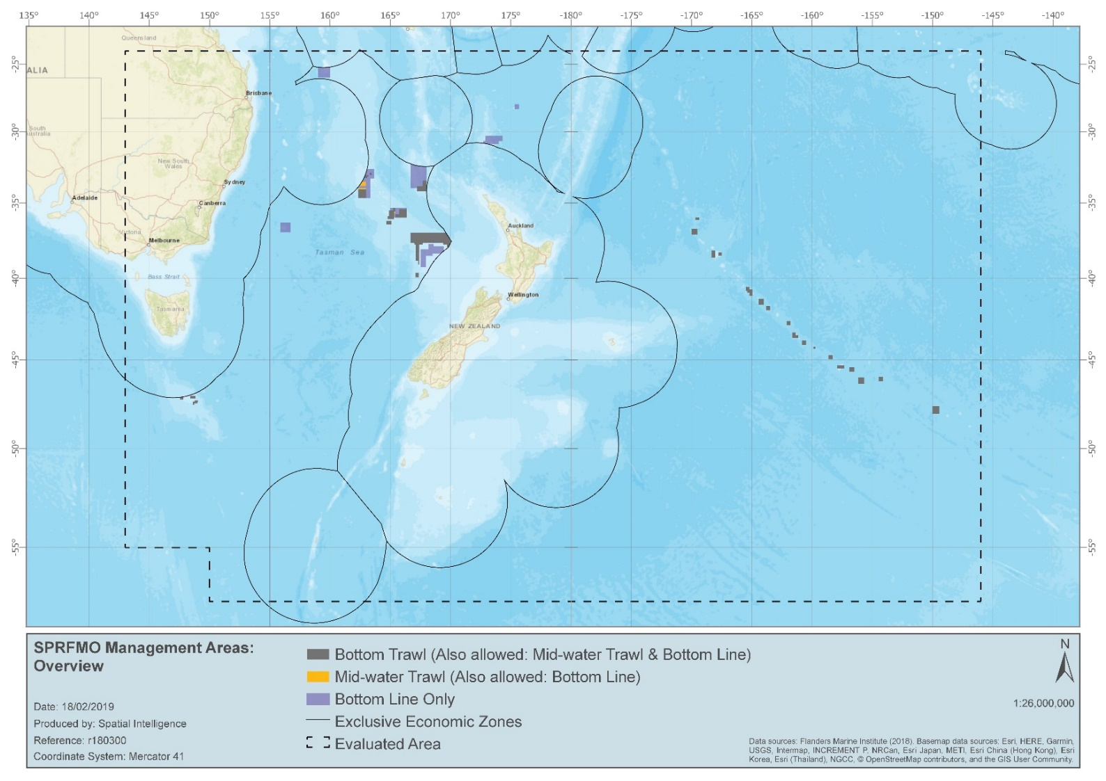

ANNEX 2: SPRFMO Bottom Fishing Management Areas for the Louisville Ridge

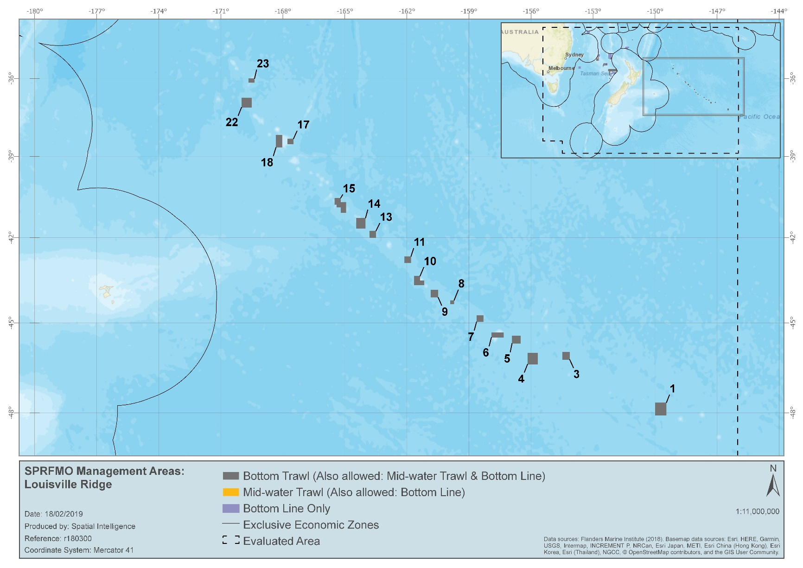

ANNEX 3: SPRFMO Bottom Fishing Management Areas for the Tasman Sea
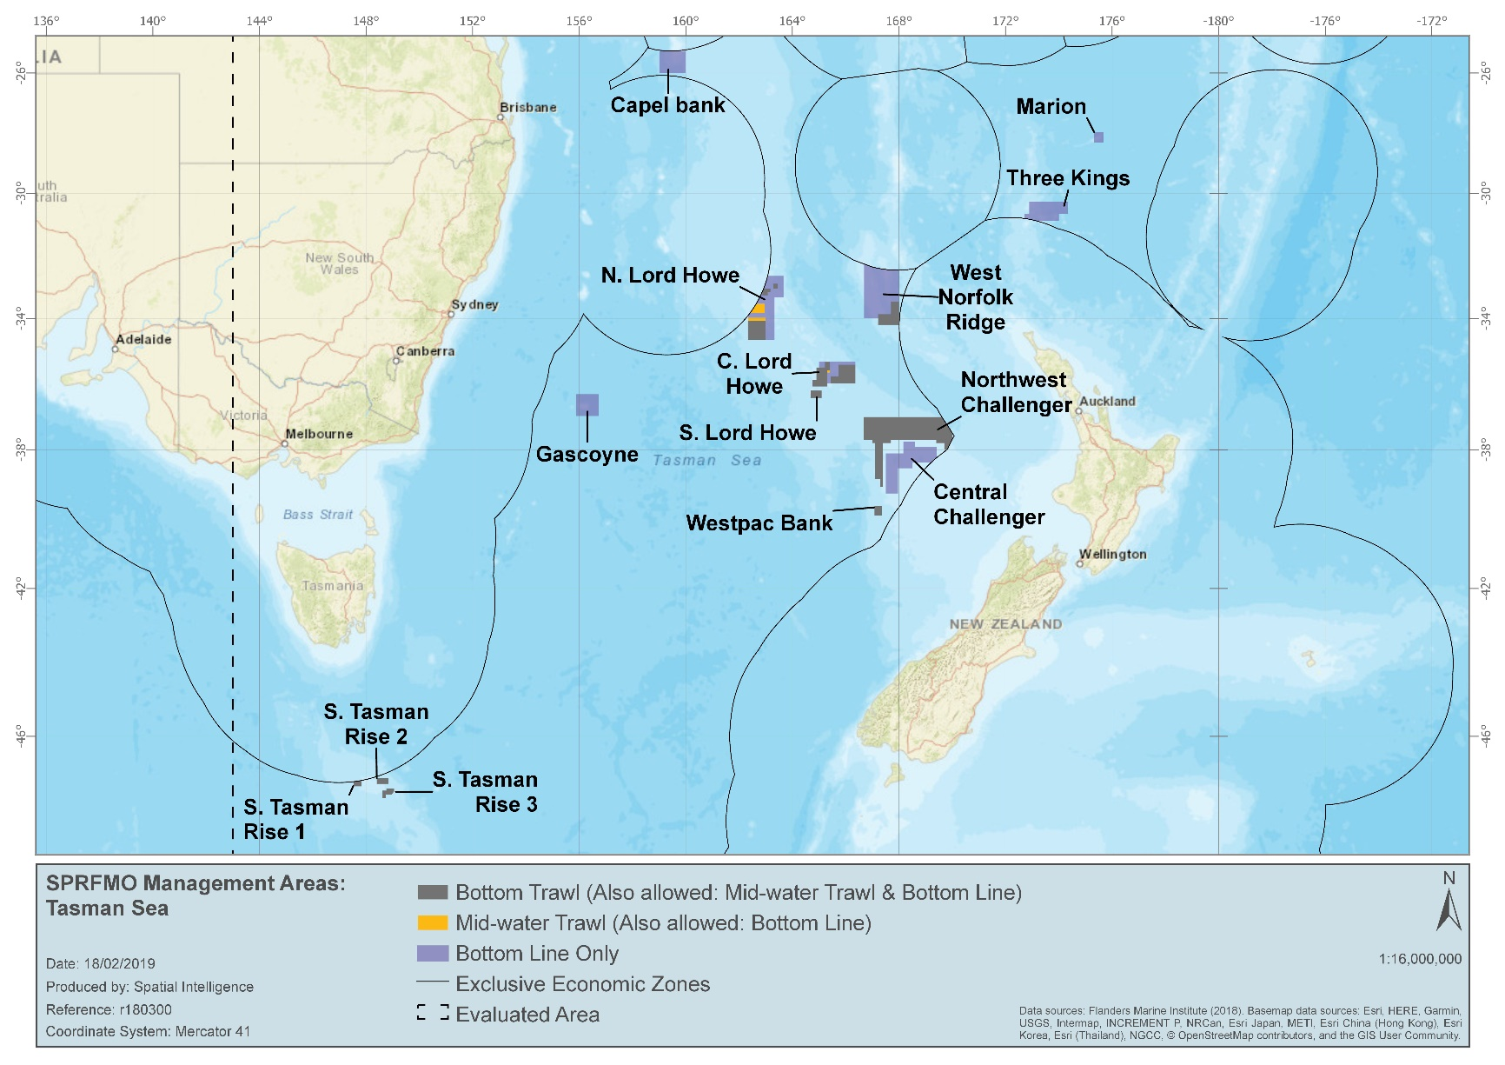

ANNEX 4: Coordinates for Each Bottom Fishing Management Area
  - Bottom Trawl Management Area coordinates
Block Name | FMA | Method | Latitude | Longitude | EEZ Direction
C. Lord Howe – West | Central Lord Howe Rise | Bottom trawl | 35°21.000′S | 165°13.553′E
C. Lord Howe – West | Central Lord Howe Rise | Bottom trawl | 35°21.000′S | 165°24.000′E
C. Lord Howe – West | Central Lord Howe Rise | Bottom trawl | 35°36.000′S | 165°24.000′E
C. Lord Howe – West | Central Lord Howe Rise | Bottom trawl | 35°36.000′S | 165°18.000′E
C. Lord Howe – West | Central Lord Howe Rise | Bottom trawl | 36°06.000′S | 165°18.000′E
C. Lord Howe – West | Central Lord Howe Rise | Bottom trawl | 36°06.000′S | 164°46.000′E
C. Lord Howe – West | Central Lord Howe Rise | Bottom trawl | 35°54.000′S | 164°46.000′E
C. Lord Howe – West | Central Lord Howe Rise | Bottom trawl | 35°54.000′S | 164°54.000′E
C. Lord Howe – West | Central Lord Howe Rise | Bottom trawl | 35°31.000′S | 165°54.000′E
C. Lord Howe – West | Central Lord Howe Rise | Bottom trawl | 35°31.000′S | 165°13.550′E
C. Lord Howe – East | Central Lord Howe Rise | Bottom trawl | 35°26.000′S | 165°44.000′E
C. Lord Howe – East | Central Lord Howe Rise | Bottom trawl | 35°26.000′S | 166°21.915′E
C. Lord Howe – East | Central Lord Howe Rise | Bottom trawl | 35°47.000′S | 165°26.000′E
C. Lord Howe – East | Central Lord Howe Rise | Bottom trawl | 35°47.000′S | 165°44.000′E
C. Lord Howe – East | Central Lord Howe Rise | Bottom trawl | 36°00.500′S | 165°26.000′E
C. Lord Howe – East | Central Lord Howe Rise | Bottom trawl | 36°00.500′S | 166°21.915′E
S. Lord Howe | Central Lord Howe Rise | Bottom trawl | 36°13.460′S | 164°40.830′E | S. Lord Howe
S. Lord Howe | Central Lord Howe Rise | Bottom trawl | 36°13.460′S | 165°06.050′E | S. Lord Howe
S. Lord Howe | Central Lord Howe Rise | Bottom trawl | 36°26.800′S | 164°40.830′E | S. Lord Howe
S. Lord Howe | Central Lord Howe Rise | Bottom trawl | 36°26.800′S | 165°06.050′E | S. Lord Howe
01 | South Louisville | Bottom trawl | 47°40.000′S | 149°27.000′W
01 | South Louisville | Bottom trawl | 47°40.000′S | 150°00.000′W
01 | South Louisville | Bottom trawl | 48°05.000′S | 149°27.000′W
01 | South Louisville | Bottom trawl | 48°05.000′S | 150°00.000′W
03 | South Louisville | Bottom trawl | 45°59.000′S | 154°07.224′W
03 | South Louisville | Bottom trawl | 45°59.000′S | 154°28.653′W
03 | South Louisville | Bottom trawl | 46°15.000′S | 154°07.224′W
03 | South Louisville | Bottom trawl | 46°15.000′S | 154°28.653′W
04 | South Louisville | Bottom trawl | 46°01.000′S | 155°40.000′W
04 | South Louisville | Bottom trawl | 46°01.000′S | 156°10.000′W
04 | South Louisville | Bottom trawl | 46°24.000′S | 155°40.000′W
04 | South Louisville | Bottom trawl | 46°24.000′S | 156°10.000′W
05 | South Louisville | Bottom trawl | 45°26.000′S | 156°30.000′W
05 | South Louisville | Bottom trawl | 45°26.000′S | 156°55.000′W
05 | South Louisville | Bottom trawl | 45°42.000′S | 156°30.000′W
05 | South Louisville | Bottom trawl | 45°42.000′S | 156°55.000′W
06 | South Louisville | Bottom trawl | 45°19.500′S | 157°19.000′W
06 | South Louisville | Bottom trawl | 45°19.500′S | 157°55.000′W
06 | South Louisville | Bottom trawl | 45°30.000′S | 157°19.000′W
06 | South Louisville | Bottom trawl | 45°30.000′S | 157°55.000′W
07 | South Louisville | Bottom trawl | 44°43.950′S | 158°18.000′W
07 | South Louisville | Bottom trawl | 44°43.950′S | 158°38.000′W
07 | South Louisville | Bottom trawl | 44°57.950′S | 158°18.000′W
07 | South Louisville | Bottom trawl | 44°57.950′S | 158°38.000′W
08 | South Louisville | Bottom trawl | 44°13.000′S | 159°43.000′W
08 | South Louisville | Bottom trawl | 44°13.000′S | 159°54.000′W
08 | South Louisville | Bottom trawl | 44°21.000′S | 159°43.000′W
08 | South Louisville | Bottom trawl | 44°21.000′S | 159°54.000′W
09 | South Louisville | Bottom trawl | 43°51.183′S | 160°29.235′W
09 | South Louisville | Bottom trawl | 43°51.183′S | 160°50.820′W
09 | South Louisville | Bottom trawl | 44°07.000′S | 160°29.235′W
09 | South Louisville | Bottom trawl | 44°07.000′S | 160°50.820′W
10 | South Louisville | Bottom trawl | 43°22.000′S | 161°21.770′W
10 | South Louisville | Bottom trawl | 43°22.000′S | 161°39.000′W
10 | South Louisville | Bottom trawl | 43°31.370′S | 161°10.170′W
10 | South Louisville | Bottom trawl | 43°31.370′S | 161°21.770′W
10 | South Louisville | Bottom trawl | 43°41.440′S | 161°10.170′W
10 | South Louisville | Bottom trawl | 43°41.440′S | 161°39.000′W
11 | South Louisville | Bottom trawl | 42°40.000′S | 161°48.000′W
11 | South Louisville | Bottom trawl | 42°40.000′S | 162°07.000′W
11 | South Louisville | Bottom trawl | 42°54.500′S | 161°48.000′W
11 | South Louisville | Bottom trawl | 42°54.500′S | 162°07.000′W
13 | Central Louisville | Bottom trawl | 41°45.000′S | 163°29.500′W
13 | Central Louisville | Bottom trawl | 41°45.000′S | 163°49.000′W
13 | Central Louisville | Bottom trawl | 42°00.000′S | 163°29.500′W
13 | Central Louisville | Bottom trawl | 42°00.000′S | 163°49.000′W
14 | Central Louisville | Bottom trawl | 41°17.000′S | 164°00.000′W
14 | Central Louisville | Bottom trawl | 41°17.000′S | 164°27.000′W
14 | Central Louisville | Bottom trawl | 41°40.000′S | 164°00.000′W
14 | Central Louisville | Bottom trawl | 41°40.000′S | 164°27.000′W
15 | Central Louisville | Bottom trawl | 40°32.897′S | 165°12.000′W
15 | Central Louisville | Bottom trawl | 40°32.897′S | 165°30.000′W
15 | Central Louisville | Bottom trawl | 40°42.000′S | 164°56.400′W
15 | Central Louisville | Bottom trawl | 40°42.000′S | 165°12.000′W
15 | Central Louisville | Bottom trawl | 40°48.000′S | 165°24.000′W
15 | Central Louisville | Bottom trawl | 40°48.000′S | 165°30.000′W
15 | Central Louisville | Bottom trawl | 40°54.000′S | 165°12.000′W
15 | Central Louisville | Bottom trawl | 40°54.000′S | 165°24.000′W
15 | Central Louisville | Bottom trawl | 41°06.000′S | 164°56.400′W
15 | Central Louisville | Bottom trawl | 41°06.000′S | 165°12.000′W
17 | North Louisville | Bottom trawl | 38°20.013′S | 167°29.000′W
17 | North Louisville | Bottom trawl | 38°20.013′S | 167°47.067′W
17 | North Louisville | Bottom trawl | 38°32.000′S | 167°29.000′W
17 | North Louisville | Bottom trawl | 38°32.000′S | 167°47.067′W
18 | North Louisville | Bottom trawl | 38°11.013′S | 168°01.785′W
18 | North Louisville | Bottom trawl | 38°11.013′S | 168°20.000′W
18 | North Louisville | Bottom trawl | 38°40.000′S | 168°01.785′W
18 | North Louisville | Bottom trawl | 38°40.000′S | 168°20.000′W
22 | North Louisville | Bottom trawl | 36°45.000′S | 169°30.000′W
22 | North Louisville | Bottom trawl | 36°45.000′S | 170°00.000′W
22 | North Louisville | Bottom trawl | 37°08.000′S | 169°30.000′W
22 | North Louisville | Bottom trawl | 37°08.000′S | 170°00.000′W
23 | North Louisville | Bottom trawl | 36°00.000′S | 169°22.000′W
23 | North Louisville | Bottom trawl | 36°00.000′S | 169°40.000′W
23 | North Louisville | Bottom trawl | 36°10.000′S | 169°22.000′W
23 | North Louisville | Bottom trawl | 36°10.000′S | 169°40.000′W
N. Lord Howe - South | North Lord Howe Rise | Bottom trawl | 34°04.035′S | 162°20.000′E
N. Lord Howe - South | North Lord Howe Rise | Bottom trawl | 34°04.035′S | 163°00.000′E
N. Lord Howe - South | North Lord Howe Rise | Bottom trawl | 34°40.000′S | 162°20.000′E
N. Lord Howe - South | North Lord Howe Rise | Bottom trawl | 34°40.000′S | 163°00.000′E
N. Lord Howe - East | North Lord Howe Rise | Bottom trawl | 32°54.650′S | 163°16.615′E
N. Lord Howe - East | North Lord Howe Rise | Bottom trawl | 32°54.650′S | 163°26.380′E
N. Lord Howe - East | North Lord Howe Rise | Bottom trawl | 33°04.400′S | 163°16.615′E
N. Lord Howe - East | North Lord Howe Rise | Bottom trawl | 33°04.400′S | 163°26.380′E
N. Lord Howe - West | North Lord Howe Rise | Bottom trawl | 33°16.400′S | 162°52.540′E
N. Lord Howe - West | North Lord Howe Rise | Bottom trawl | 33°09.296′S | 162°52.540′E | North-east along the Australian EEZ
N. Lord Howe - West | North Lord Howe Rise | Bottom trawl | 33°04.400′S | 162°54.941′E
N. Lord Howe - West | North Lord Howe Rise | Bottom trawl | 33°04.400′S | 163°10.540′E
N. Lord Howe - West | North Lord Howe Rise | Bottom trawl | 33°10.400′S | 163°10.540′E
N. Lord Howe - West | North Lord Howe Rise | Bottom trawl | 33°10.400′S | 163°04.540′E
N. Lord Howe - West | North Lord Howe Rise | Bottom trawl | 33°16.400′S | 163°04.540′E
Northwest Challenger | Northwest Challenger | Bottom trawl | 38°00.000′S | 169°47.848′E
Northwest Challenger | Northwest Challenger | Bottom trawl | 38°00.000′S | 169°42.000′E
Northwest Challenger | Northwest Challenger | Bottom trawl | 37°48.000′S | 169°42.000′E
Northwest Challenger | Northwest Challenger | Bottom trawl | 37°48.000′S | 169°24.000′E
Northwest Challenger | Northwest Challenger | Bottom trawl | 37°42.000′S | 169°24.000′E
Northwest Challenger | Northwest Challenger | Bottom trawl | 37°42.000′S | 167°42.000′E
Northwest Challenger | Northwest Challenger | Bottom trawl | 37°48.000′S | 167°42.000′E
Northwest Challenger | Northwest Challenger | Bottom trawl | 37°48.000′S | 167°24.000′E
Northwest Challenger | Northwest Challenger | Bottom trawl | 39°06.000′S | 167°24.000′E
Northwest Challenger | Northwest Challenger | Bottom trawl | 39°06.000′S | 167°18.000′E
Northwest Challenger | Northwest Challenger | Bottom trawl | 38°52.000′S | 167°18.000′E
Northwest Challenger | Northwest Challenger | Bottom trawl | 38°52.000′S | 167°06.000′E
Northwest Challenger | Northwest Challenger | Bottom trawl | 37°48.000′S | 167°06.000′E
Northwest Challenger | Northwest Challenger | Bottom trawl | 37°48.000′S | 167°00.000′E
Northwest Challenger | Northwest Challenger | Bottom trawl | 37°42.000′S | 167°00.000′E
Northwest Challenger | Northwest Challenger | Bottom trawl | 37°42.000′S | 166°40.000′E
Northwest Challenger | Northwest Challenger | Bottom trawl | 37°01.333′S | 166°40.000′E
Northwest Challenger | Northwest Challenger | Bottom trawl | 37°01.333′S | 169°36.706′E | South-east along the New Zealand EEZ
Northwest Challenger | Northwest Challenger | Bottom trawl | 37°29.902′S | 170°00.000′E | Due south to a point on the New Zealand EEZ
Northwest Challenger | Northwest Challenger | Bottom trawl | 37°41.589′S | 170°00.000′E | South-west along the New Zealand EEZ
S. Tasman Rise 1 | South Tasman Rise | Bottom trawl | 47°08.280′S | 147°50.200′E | Start on the Australian EEZ
S. Tasman Rise 1 | South Tasman Rise | Bottom trawl | 47°17.370′S | 147°50.200′E
S. Tasman Rise 1 | South Tasman Rise | Bottom trawl | 47°17.370′S | 147°32.300′E
S. Tasman Rise 1 | South Tasman Rise | Bottom trawl | 47°10.197′S | 147°32.300′E | East along the Australian EEZ to the start point
S. Tasman Rise 1 | South Tasman Rise | Bottom trawl | 47°05.160′S | 148°24.165′E
S. Tasman Rise 2 | South Tasman Rise | Bottom trawl | 47°05.160′S | 148°50.670′E
S. Tasman Rise 2 | South Tasman Rise | Bottom trawl | 47°13.780′S | 148°24.165′E
S. Tasman Rise 2 | South Tasman Rise | Bottom trawl | 47°13.780′S | 148°50.670′E
S. Tasman Rise 2 | South Tasman Rise | Bottom trawl | 47°21.000′S | 148°45.610′E
S. Tasman Rise 3 | South Tasman Rise | Bottom trawl | 47°21.000′S | 149°03.200′E
S. Tasman Rise 3 | South Tasman Rise | Bottom trawl | 47°24.015′S | 148°37.235′E
S. Tasman Rise 3 | South Tasman Rise | Bottom trawl | 47°24.015′S | 148°45.610′E
S. Tasman Rise 3 | South Tasman Rise | Bottom trawl | 47°24.800′S | 149°03.200′E
S. Tasman Rise 3 | South Tasman Rise | Bottom trawl | 47°30.320′S | 148°44.390′E
S. Tasman Rise 3 | South Tasman Rise | Bottom trawl | 47°30.320′S | 148°57.650′E
S. Tasman Rise 3 | South Tasman Rise | Bottom trawl | 47°35.205′S | 148°37.235′E
S. Tasman Rise 3 | South Tasman Rise | Bottom trawl | 47°35.205′S | 148°44.390′E
Wanganella | West Norfolk | Bottom trawl | 33°28.000′S | 167°42.000′E
Wanganella | West Norfolk | Bottom trawl | 33°28.000′S | 168°00.000′E
Wanganella | West Norfolk | Bottom trawl | 33°52.000′S | 167°13.000′E
Wanganella | West Norfolk | Bottom trawl | 33°52.000′S | 167°42.000′E
Wanganella | West Norfolk | Bottom trawl | 34°12.000′S | 167°13.000′E
Wanganella | West Norfolk | Bottom trawl | 34°12.000′S | 168°00.000′E
Westpac Bank | Westpac Bank | Bottom trawl | 39°39.000′S | 167°05.000′E
Westpac Bank | Westpac Bank | Bottom trawl | 39°39.000′S | 167°21.090′E
Westpac Bank | Westpac Bank | Bottom trawl | 39°55.000′S | 167°05.000′E
Westpac Bank | Westpac Bank | Bottom trawl | 39°55.000′S | 167°21.090′E

  - Mid-water Trawl Management Area coordinates
Block name | FMA | Method | Latitude | Longitude | EEZ Direction
C. Lord Howe - East | Central Lord Howe Rise | Mid-water trawl | 35°26.000′S | 165°44.000′E
C. Lord Howe - East | Central Lord Howe Rise | Mid-water trawl | 35°26.000′S | 166°21.915′E
C. Lord Howe - East | Central Lord Howe Rise | Mid-water trawl | 35°47.000′S | 165°26.000′E
C. Lord Howe - East | Central Lord Howe Rise | Mid-water trawl | 35°47.000′S | 165°44.000′E
C. Lord Howe - East | Central Lord Howe Rise | Mid-water trawl | 36°00.500′S | 165°26.000′E
C. Lord Howe - East | Central Lord Howe Rise | Mid-water trawl | 36°00.500′S | 166°21.915′E
C. Lord Howe - West | Central Lord Howe Rise | Mid-water trawl | 35°21.000′S | 165°13.550′E
C. Lord Howe - West | Central Lord Howe Rise | Mid-water trawl | 35°21.000′S | 165°24.000′E
C. Lord Howe - West | Central Lord Howe Rise | Mid-water trawl | 35°31.000′S | 164°54.000′E
C. Lord Howe - West | Central Lord Howe Rise | Mid-water trawl | 35°31.000′S | 165°13.550′E
C. Lord Howe - West | Central Lord Howe Rise | Mid-water trawl | 35°40.383′S | 165°18.000′E
C. Lord Howe - West | Central Lord Howe Rise | Mid-water trawl | 35°40.383′S | 165°24.000′E
C. Lord Howe - West | Central Lord Howe Rise | Mid-water trawl | 35°54.000′S | 164°46.000′E
C. Lord Howe - West | Central Lord Howe Rise | Mid-water trawl | 35°54.000′S | 164°54.000′E
C. Lord Howe - West | Central Lord Howe Rise | Mid-water trawl | 36°06.000′S | 164°46.000′E
C. Lord Howe - West | Central Lord Howe Rise | Mid-water trawl | 36°06.000′S | 165°18.000′E
S. Lord Howe | Central Lord Howe Rise | Mid-water trawl | 36°13.460′S | 164°40.830′E
S. Lord Howe | Central Lord Howe Rise | Mid-water trawl | 36°13.460′S | 165°06.050′E
S. Lord Howe | Central Lord Howe Rise | Mid-water trawl | 36°26.800′S | 164°40.830′E
S. Lord Howe | Central Lord Howe Rise | Mid-water trawl | 36°26.800′S | 165°06.050′E
1 | South Louisville | Mid-water trawl | 47°40.000′S | 149°27.000′W
1 | South Louisville | Mid-water trawl | 47°40.000′S | 150°00.000′W
1 | South Louisville | Mid-water trawl | 48°05.000′S | 149°27.000′W
1 | South Louisville | Mid-water trawl | 48°05.000′S | 150°00.000′W
3 | South Louisville | Mid-water trawl | 45°59.000′S | 154°07.224′W
3 | South Louisville | Mid-water trawl | 45°59.000′S | 154°28.653′W
3 | South Louisville | Mid-water trawl | 46°15.000′S | 154°07.224′W
3 | South Louisville | Mid-water trawl | 46°15.000′S | 154°28.653′W
4 | South Louisville | Mid-water trawl | 46°01.000′S | 155°40.000′W
4 | South Louisville | Mid-water trawl | 46°01.000′S | 156°10.000′W
4 | South Louisville | Mid-water trawl | 46°24.000′S | 155°40.000′W
4 | South Louisville | Mid-water trawl | 46°24.000′S | 156°10.000′W
5 | South Louisville | Mid-water trawl | 45°26.000′S | 156°30.000′W
5 | South Louisville | Mid-water trawl | 45°26.000′S | 156°55.000′W
5 | South Louisville | Mid-water trawl | 45°42.000′S | 156°30.000′W
5 | South Louisville | Mid-water trawl | 45°42.000′S | 156°55.000′W
6 | South Louisville | Mid-water trawl | 45°19.500′S | 157°19.000′W
6 | South Louisville | Mid-water trawl | 45°19.500′S | 157°55.000′W
6 | South Louisville | Mid-water trawl | 45°30.000′S | 157°19.000′W
6 | South Louisville | Mid-water trawl | 45°30.000′S | 157°55.000′W
7 | South Louisville | Mid-water trawl | 44°43.950′S | 158°18.000′W
7 | South Louisville | Mid-water trawl | 44°43.950′S | 158°38.000′W
7 | South Louisville | Mid-water trawl | 44°57.950′S | 158°18.000′W
7 | South Louisville | Mid-water trawl | 44°57.950′S | 158°38.000′W
8 | South Louisville | Mid-water trawl | 44°13.000′S | 159°43.000′W
8 | South Louisville | Mid-water trawl | 44°13.000′S | 159°54.000′W
8 | South Louisville | Mid-water trawl | 44°21.000′S | 159°43.000′W
8 | South Louisville | Mid-water trawl | 44°21.000′S | 159°54.000′W
9 | South Louisville | Mid-water trawl | 43°51.183′S | 160°29.235′W
9 | South Louisville | Mid-water trawl | 43°51.183′S | 160°50.820′W
9 | South Louisville | Mid-water trawl | 44°07.000′S | 160°29.235′W
9 | South Louisville | Mid-water trawl | 44°07.000′S | 160°50.820′W
10 | South Louisville | Mid-water trawl | 43°22.000′S | 161°21.770′W
10 | South Louisville | Mid-water trawl | 43°22.000′S | 161°39.000′W
10 | South Louisville | Mid-water trawl | 43°31.370′S | 161°10.170′W
10 | South Louisville | Mid-water trawl | 43°31.370′S | 161°21.770′W
10 | South Louisville | Mid-water trawl | 43°41.440′S | 161°10.170′W
10 | South Louisville | Mid-water trawl | 43°41.440′S | 161°39.000′W
11 | South Louisville | Mid-water trawl | 42°40.000′S | 161°48.000′W
11 | South Louisville | Mid-water trawl | 42°40.000′S | 162°07.000′W
11 | South Louisville | Mid-water trawl | 42°54.500′S | 161°48.000′W
11 | South Louisville | Mid-water trawl | 42°54.500′S | 162°07.000′W
13 | Central Louisville | Mid-water trawl | 41°45.000′S | 163°29.500′W
13 | Central Louisville | Mid-water trawl | 41°45.000′S | 163°49.000′W
13 | Central Louisville | Mid-water trawl | 42°00.000′S | 163°29.500′W
13 | Central Louisville | Mid-water trawl | 42°00.000′S | 163°49.000′W
14 | Central Louisville | Mid-water trawl | 41°17.000′S | 164°00.000′W
14 | Central Louisville | Mid-water trawl | 41°17.000′S | 164°27.000′W
14 | Central Louisville | Mid-water trawl | 41°40.000′S | 164°00.000′W
14 | Central Louisville | Mid-water trawl | 41°40.000′S | 164°27.000′W
15 | Central Louisville | Mid-water trawl | 40°32.897′S | 165°12.000′W
15 | Central Louisville | Mid-water trawl | 40°32.897′S | 165°30.000′W
15 | Central Louisville | Mid-water trawl | 40°42.000′S | 164°56.400′W
15 | Central Louisville | Mid-water trawl | 40°42.000′S | 165°12.000′W
15 | Central Louisville | Mid-water trawl | 40°48.000′S | 165°24.000′W
15 | Central Louisville | Mid-water trawl | 40°48.000′S | 165°30.000′W
15 | Central Louisville | Mid-water trawl | 40°54.000′S | 165°12.000′W
15 | Central Louisville | Mid-water trawl | 40°54.000′S | 165°24.000′W
15 | Central Louisville | Mid-water trawl | 41°06.000′S | 164°56.400′W
15 | Central Louisville | Mid-water trawl | 41°06.000′S | 165°12.000′W
17 | North Louisville | Mid-water trawl | 38°20.013′S | 167°29.000′W
17 | North Louisville | Mid-water trawl | 38°20.013′S | 167°47.067′W
17 | North Louisville | Mid-water trawl | 38°32.000′S | 167°29.000′W
17 | North Louisville | Mid-water trawl | 38°32.000′S | 167°47.067′W
18 | North Louisville | Mid-water trawl | 38°11.013′S | 168°01.785′W
18 | North Louisville | Mid-water trawl | 38°11.013′S | 168°20.000′W
18 | North Louisville | Mid-water trawl | 38°40.000′S | 168°01.785′W
18 | North Louisville | Mid-water trawl | 38°40.000′S | 168°20.000′W
22 | North Louisville | Mid-water trawl | 36°45.000′S | 169°30.000′W
22 | North Louisville | Mid-water trawl | 36°45.000′S | 170°00.000′W
22 | North Louisville | Mid-water trawl | 37°08.000′S | 169°30.000′W
22 | North Louisville | Mid-water trawl | 37°08.000′S | 170°00.000′W
23 | North Louisville | Mid-water trawl | 36°00.000′S | 169°22.000′W
23 | North Louisville | Mid-water trawl | 36°00.000′S | 169°40.000′W
23 | North Louisville | Mid-water trawl | 36°10.000′S | 169°22.000′W
23 | North Louisville | Mid-water trawl | 36°10.000′S | 169°40.000′W
N. Lord Howe - Central | North Lord Howe Rise | Mid-water trawl | 33°49.630′S | 162°25.670′E
N. Lord Howe - Central | North Lord Howe Rise | Mid-water trawl | 33°48.622′S | 162°25.670′E | North-east along the Australian EEZ
N. Lord Howe - Central | North Lord Howe Rise | Mid-water trawl | 33°32.530′S | 162°38.450′E
N. Lord Howe - Central | North Lord Howe Rise | Mid-water trawl | 33°32.530′S | 162°57.770′E
N. Lord Howe - Central | North Lord Howe Rise | Mid-water trawl | 33°49.630′S | 162°57.770′E
N. Lord Howe - East | North Lord Howe Rise | Mid-water trawl | 32°54.650′S | 163°16.615′E
N. Lord Howe - East | North Lord Howe Rise | Mid-water trawl | 32°54.650′S | 163°26.380′E
N. Lord Howe - East | North Lord Howe Rise | Mid-water trawl | 33°04.400′S | 163°16.615′E
N. Lord Howe - East | North Lord Howe Rise | Mid-water trawl | 33°04.400′S | 163°26.380′E
N. Lord Howe - South | North Lord Howe Rise | Mid-water trawl | 33°58.670′S | 162°20.000′E
N. Lord Howe - South | North Lord Howe Rise | Mid-water trawl | 33°58.670′S | 163°00.000′E
N. Lord Howe - South | North Lord Howe Rise | Mid-water trawl | 34°40.000′S | 162°20.000′E
N. Lord Howe - South | North Lord Howe Rise | Mid-water trawl | 34°40.000′S | 163°00.000′E
N. Lord Howe - West | North Lord Howe Rise | Mid-water trawl | 33°16.400′S | 162°52.540′E
N. Lord Howe - West | North Lord Howe Rise | Mid-water trawl | 33°09.296′S | 162°52.540′E | North-east along the Australian EEZ
N. Lord Howe - West | North Lord Howe Rise | Mid-water trawl | 33°04.400′S | 162°54.941′E
N. Lord Howe - West | North Lord Howe Rise | Mid-water trawl | 33°04.400′S | 163°10.540′E
N. Lord Howe - West | North Lord Howe Rise | Mid-water trawl | 33°10.400′S | 163°04.540′E
N. Lord Howe - West | North Lord Howe Rise | Mid-water trawl | 33°10.400′S | 163°10.540′E
N. Lord Howe - West | North Lord Howe Rise | Mid-water trawl | 33°16.400′S | 163°04.540′E
Northwest Challenger | Northwest Challenger | Mid-water trawl | 37°01.333′S | 166°40.000′E
Northwest Challenger | Northwest Challenger | Mid-water trawl | 37°01.333′S | 169°36.706′E | South-east along the New Zealand EEZ
Northwest Challenger | Northwest Challenger | Mid-water trawl | 37°29.902′S | 170°00.000′E | Due south to a point on the New Zealand EEZ
Northwest Challenger | Northwest Challenger | Mid-water trawl | 37°41.589′S | 170°00.000′E | South-west along the New Zealand EEZ
Northwest Challenger | Northwest Challenger | Mid-water trawl | 38°00.000′S | 169°47.848′E
Northwest Challenger | Northwest Challenger | Mid-water trawl | 38°00.000′S | 169°42.000′E
Northwest Challenger | Northwest Challenger | Mid-water trawl | 37°48.000′S | 169°42.000′E
Northwest Challenger | Northwest Challenger | Mid-water trawl | 37°48.000′S | 169°24.000′E
Northwest Challenger | Northwest Challenger | Mid-water trawl | 37°42.000′S | 169°24.000′E
Northwest Challenger | Northwest Challenger | Mid-water trawl | 37°42.000′S | 167°42.004′E
Northwest Challenger | Northwest Challenger | Mid-water trawl | 37°48.000′S | 167°42.000′E
Northwest Challenger | Northwest Challenger | Mid-water trawl | 37°48.000′S | 167°24.000′E
Northwest Challenger | Northwest Challenger | Mid-water trawl | 39°06.000′S | 167°24.000′E
Northwest Challenger | Northwest Challenger | Mid-water trawl | 39°06.000′S | 167°18.000′E
Northwest Challenger | Northwest Challenger | Mid-water trawl | 38°52.000′S | 167°18.000′E
Northwest Challenger | Northwest Challenger | Mid-water trawl | 38°52.000′S | 167°06.000′E
Northwest Challenger | Northwest Challenger | Mid-water trawl | 37°48.000′S | 167°06.000′E
Northwest Challenger | Northwest Challenger | Mid-water trawl | 37°48.000′S | 167°00.000′E
Northwest Challenger | Northwest Challenger | Mid-water trawl | 37°42.000′S | 167°00.000′E
Northwest Challenger | Northwest Challenger | Mid-water trawl | 37°42.000′S | 166°40.000′E
S. Tasman Rise 1 | South Tasman Rise | Mid-water trawl | 47°08.280′S | 147°50.200′E | Start on the Australian EEZ
S. Tasman Rise 1 | South Tasman Rise | Mid-water trawl | 47°17.370′S | 147°50.200′E
S. Tasman Rise 1 | South Tasman Rise | Mid-water trawl | 47°17.370′S | 147°32.300′E
S. Tasman Rise 1 | South Tasman Rise | Mid-water trawl | 47°10.197′S | 147°32.300′E | East along the Australian EEZ to the start point
S. Tasman Rise 2 | South Tasman Rise | Mid-water trawl | 47°05.160′S | 148°24.165′E
S. Tasman Rise 2 | South Tasman Rise | Mid-water trawl | 47°05.160′S | 148°50.670′E
S. Tasman Rise 2 | South Tasman Rise | Mid-water trawl | 47°13.780′S | 148°24.165′E
S. Tasman Rise 2 | South Tasman Rise | Mid-water trawl | 47°13.780′S | 148°50.670′E
S. Tasman Rise 3 | South Tasman Rise | Mid-water trawl | 47°21.000′S | 148°45.610′E
S. Tasman Rise 3 | South Tasman Rise | Mid-water trawl | 47°21.000′S | 149°03.200′E
S. Tasman Rise 3 | South Tasman Rise | Mid-water trawl | 47°24.015′S | 148°37.235′E
S. Tasman Rise 3 | South Tasman Rise | Mid-water trawl | 47°24.015′S | 148°45.610′E
S. Tasman Rise 3 | South Tasman Rise | Mid-water trawl | 47°24.800′S | 149°03.200′E
S. Tasman Rise 3 | South Tasman Rise | Mid-water trawl | 47°30.320′S | 148°44.390′E
S. Tasman Rise 3 | South Tasman Rise | Mid-water trawl | 47°30.320′S | 148°57.650′E
S. Tasman Rise 3 | South Tasman Rise | Mid-water trawl | 47°35.205′S | 148°37.235′E
S. Tasman Rise 3 | South Tasman Rise | Mid-water trawl | 47°35.205′S | 148°44.390′E
Wanganella | West Norfolk | Mid-water trawl | 33°28.000′S | 167°42.000′E
Wanganella | West Norfolk | Mid-water trawl | 33°28.000′S | 168°00.000′E
Wanganella | West Norfolk | Mid-water trawl | 33°52.000′S | 167°13.000′E
Wanganella | West Norfolk | Mid-water trawl | 33°52.000′S | 167°42.000′E
Wanganella | West Norfolk | Mid-water trawl | 34°12.000′S | 167°13.000′E
Wanganella | West Norfolk | Mid-water trawl | 34°12.000′S | 168°00.000′E
Westpac Bank | Westpac Bank | Mid-water trawl | 39°39.000′S | 167°05.000′E
Westpac Bank | Westpac Bank | Mid-water trawl | 39°39.000′S | 167°21.090′E
Westpac Bank | Westpac Bank | Mid-water trawl | 39°55.000′S | 167°05.000′E
Westpac Bank | Westpac Bank | Mid-water trawl | 39°55.000′S | 167°21.090′E

  - Bottom Line Management Area coordinates
Block name | FMA | Method | Latitude | Longitude | EEZ Direction
Capel bank |  | Bottom Line | 25°14.950′S | 159°00.285′E
Capel bank |  | Bottom Line | 25°14.950′S | 160°00.000′E
Capel bank |  | Bottom Line | 25°59.640′S | 159°00.285′E
Capel bank |  | Bottom Line | 25°59.640′S | 160°00.000′E
Gascoyne |  | Bottom Line | 36°19.950′S | 155°53.630′E
Gascoyne |  | Bottom Line | 36°19.950′S | 156°43.770′E
Gascoyne |  | Bottom Line | 36°59.440′S | 155°53.630′E
Gascoyne |  | Bottom Line | 36°59.440′S | 156°43.770′E
S. Lord Howe | Central Lord Howe Rise | Bottom Line | 35°20.000′S | 165°00.000′E
S. Lord Howe | Central Lord Howe Rise | Bottom Line | 35°20.000′S | 166°21.915′E
S. Lord Howe | Central Lord Howe Rise | Bottom Line | 35°31.000′S | 164°54.000′E
S. Lord Howe | Central Lord Howe Rise | Bottom Line | 35°31.000′S | 165°00.000′E
S. Lord Howe | Central Lord Howe Rise | Bottom Line | 35°54.000′S | 164°46.000′E
S. Lord Howe | Central Lord Howe Rise | Bottom Line | 35°54.000′S | 164°54.000′E
S. Lord Howe | Central Lord Howe Rise | Bottom Line | 36°00.500′S | 165°18.000′E
S. Lord Howe | Central Lord Howe Rise | Bottom Line | 36°00.500′S | 166°21.915′E
S. Lord Howe | Central Lord Howe Rise | Bottom Line | 36°06.000′S | 164°46.000′E
S. Lord Howe | Central Lord Howe Rise | Bottom Line | 36°06.000′S | 165°18.000′E
S. Lord Howe | Central Lord Howe Rise | Bottom Line | 36°13.460′S | 164°40.830′E
S. Lord Howe | Central Lord Howe Rise | Bottom Line | 36°13.460′S | 165°06.050′E
S. Lord Howe | Lord Howe Rise | Bottom Line | 36°26.800′S | 164°40.830′E
S. Lord Howe | Central Lord Howe Rise | Bottom Line | 36°26.800′S | 165°06.050′E
Central Challenger | Central Challenger | Bottom Line | 37°45.615′S | 168°35.830′E
Central Challenger | Central Challenger | Bottom Line | 37°55.230′S | 168°35.830′E
Central Challenger | Central Challenger | Bottom Line | 37°55.230′S | 169°25.400′E
Central Challenger | Central Challenger | Bottom Line | 38°13.830′S | 169°25.400′E | South-west along the New Zealand EEZ
Central Challenger | Central Challenger | Bottom Line | 38°23.165′S | 169°11.967′E
Central Challenger | Central Challenger | Bottom Line | 38°23.165′S | 168°30.780′E
Central Challenger | Central Challenger | Bottom Line | 38°32.750′S | 168°30.780′E
Central Challenger | Central Challenger | Bottom Line | 38°32.750′S | 167°57.950′E
Central Challenger | Central Challenger | Bottom Line | 39°17.180′S | 167°57.950′E
Central Challenger | Central Challenger | Bottom Line | 39°17.180′S | 167°30.500′E
Central Challenger | Central Challenger | Bottom Line | 38°06.430′S | 167°30.500′E
Central Challenger | Central Challenger | Bottom Line | 38°06.430′S | 168°09.833′E
Central Challenger | Central Challenger | Bottom Line | 37°45.615′S | 168°09.833′E
1 | South Louisville | Bottom Line | 47°40.000′S | 149°27.000′W
1 | South Louisville | Bottom Line | 47°40.000′S | 150°00.000′W
1 | South Louisville | Bottom Line | 48°05.000′S | 149°27.000′W
1 | South Louisville | Bottom Line | 48°05.000′S | 150°00.000′W
3 | South Louisville | Bottom Line | 45°59.000′S | 154°07.224′W
3 | South Louisville | Bottom Line | 45°59.000′S | 154°28.653′W
3 | South Louisville | Bottom Line | 46°15.000′S | 154°07.224′W
3 | South Louisville | Bottom Line | 46°15.000′S | 154°28.653′W
4 | South Louisville | Bottom Line | 46°01.000′S | 155°40.000′W
4 | South Louisville | Bottom Line | 46°01.000′S | 156°10.000′W
4 | South Louisville | Bottom Line | 46°24.000′S | 155°40.000′W
4 | South Louisville | Bottom Line | 46°24.000′S | 156°10.000′W
5 | South Louisville | Bottom Line | 45°26.000′S | 156°30.000′W
5 | South Louisville | Bottom Line | 45°26.000′S | 156°55.000′W
5 | South Louisville | Bottom Line | 45°42.000′S | 156°30.000′W
5 | South Louisville | Bottom Line | 45°42.000′S | 156°55.000′W
6 | South Louisville | Bottom Line | 45°19.500′S | 157°19.000′W
6 | South Louisville | Bottom Line | 45°19.500′S | 157°55.000′W
6 | South Louisville | Bottom Line | 45°30.000′S | 157°19.000′W
6 | South Louisville | Bottom Line | 45°30.000′S | 157°55.000′W
7 | South Louisville | Bottom Line | 44°43.950′S | 158°18.000′W
7 | South Louisville | Bottom Line | 44°43.950′S | 158°38.000′W
7 | South Louisville | Bottom Line | 44°57.950′S | 158°18.000′W
7 | South Louisville | Bottom Line | 44°57.950′S | 158°38.000′W
8 | South Louisville | Bottom Line | 44°13.000′S | 159°43.000′W
8 | South Louisville | Bottom Line | 44°13.000′S | 159°54.000′W
8 | South Louisville | Bottom Line | 44°21.000′S | 159°43.000′W
8 | South Louisville | Bottom Line | 44°21.000′S | 159°54.000′W
9 | South Louisville | Bottom Line | 43°51.183′S | 160°29.235′W
9 | South Louisville | Bottom Line | 43°51.183′S | 160°50.820′W
9 | South Louisville | Bottom Line | 44°07.000′S | 160°29.235′W
9 | South Louisville | Bottom Line | 44°07.000′S | 160°50.820′W
10 | South Louisville | Bottom Line | 43°22.000′S | 161°21.770′W
10 | South Louisville | Bottom Line | 43°22.000′S | 161°39.000′W
10 | South Louisville | Bottom Line | 43°31.370′S | 161°10.170′W
10 | South Louisville | Bottom Line | 43°31.370′S | 161°21.770′W
10 | South Louisville | Bottom Line | 43°41.440′S | 161°10.170′W
10 | South Louisville | Bottom Line | 43°41.440′S | 161°39.000′W
11 | South Louisville | Bottom Line | 42°40.000′S | 161°48.000′W
11 | South Louisville | Bottom Line | 42°40.000′S | 162°07.000′W
11 | South Louisville | Bottom Line | 42°54.500′S | 161°48.000′W
11 | South Louisville | Bottom Line | 42°54.500′S | 162°07.000′W
13 | Central Louisville | Bottom Line | 41°45.000′S | 163°29.500′W
13 | Central Louisville | Bottom Line | 41°45.000′S | 163°49.000′W
13 | Central Louisville | Bottom Line | 42°00.000′S | 163°29.500′W
13 | Central Louisville | Bottom Line | 42°00.000′S | 163°49.000′W
14 | Central Louisville | Bottom Line | 41°17.000′S | 164°00.000′W
14 | Central Louisville | Bottom Line | 41°17.000′S | 164°27.000′W
14 | Central Louisville | Bottom Line | 41°40.000′S | 164°00.000′W
14 | Central Louisville | Bottom Line | 41°40.000′S | 164°27.000′W
15 | Central Louisville | Bottom Line | 40°32.897′S | 165°12.000′W
15 | Central Louisville | Bottom Line | 40°32.897′S | 165°30.000′W
15 | Central Louisville | Bottom Line | 40°42.000′S | 164°56.400′W
15 | Central Louisville | Bottom Line | 40°42.000′S | 165°12.000′W
15 | Central Louisville | Bottom Line | 40°48.000′S | 165°24.000′W
15 | Central Louisville | Bottom Line | 40°48.000′S | 165°30.000′W
15 | Central Louisville | Bottom Line | 40°54.000′S | 165°12.000′W
15 | Central Louisville | Bottom Line | 40°54.000′S | 165°24.000′W
15 | Central Louisville | Bottom Line | 41°06.000′S | 164°56.400′W
15 | Central Louisville | Bottom Line | 41°06.000′S | 165°12.000′W
17 | North Louisville | Bottom Line | 38°20.013′S | 167°29.000′W
17 | North Louisville | Bottom Line | 38°20.013′S | 167°47.067′W
17 | North Louisville | Bottom Line | 38°32.000′S | 167°29.000′W
17 | North Louisville | Bottom Line | 38°32.000′S | 167°47.067′W
18 | North Louisville | Bottom Line | 38°11.013′S | 168°01.785′W
18 | North Louisville | Bottom Line | 38°11.013′S | 168°20.000′W
18 | North Louisville | Bottom Line | 38°40.000′S | 168°01.785′W
18 | North Louisville | Bottom Line | 38°40.000′S | 168°20.000′W
22 | North Louisville | Bottom Line | 36°45.000′S | 169°30.000′W
22 | North Louisville | Bottom Line | 36°45.000′S | 170°00.000′W
22 | North Louisville | Bottom Line | 37°08.000′S | 169°30.000′W
22 | North Louisville | Bottom Line | 37°08.000′S | 170°00.000′W
23 | North Louisville | Bottom Line | 36°00.000′S | 169°22.000′W
23 | North Louisville | Bottom Line | 36°00.000′S | 169°40.000′W
23 | North Louisville | Bottom Line | 36°10.000′S | 169°22.000′W
23 | North Louisville | Bottom Line | 36°10.000′S | 169°40.000′W
N. Lord Howe | North Lord Howe Rise | Bottom Line | 32°39.630′S | 163°04.415′E | Start on the Australian EEZ
N. Lord Howe | North Lord Howe Rise | Bottom Line | 32°39.630′S | 163°40.000′E
N. Lord Howe | North Lord Howe Rise | Bottom Line | 33°20.000′S | 163°40.000′E
N. Lord Howe | North Lord Howe Rise | Bottom Line | 33°20.000′S | 163°20.000′E
N. Lord Howe | North Lord Howe Rise | Bottom Line | 34°40.000′S | 162°20.000′E
N. Lord Howe | North Lord Howe Rise | Bottom Line | 34°40.000′S | 163°20.000′E
N. Lord Howe | North Lord Howe Rise | Bottom Line | 33°54.773′S | 162°20.000′E | North-east along the Australian EEZ to the start point
Central Challenger | Northwest Challenger | Bottom Line | 37°45.615′S | 168°35.830′E
Central Challenger | Northwest Challenger | Bottom Line | 37°55.230′S | 168°35.830′E
Central Challenger | Northwest Challenger | Bottom Line | 37°55.230′S | 169°25.400′E
Central Challenger | Northwest Challenger | Bottom Line | 38°13.830′S | 169°25.400′E
Central Challenger | Northwest Challenger | Bottom Line | 38°23.165′S | 169°11.967′E
Central Challenger | Northwest Challenger | Bottom Line | 38°23.165′S | 168°30.780′E
Central Challenger | Northwest Challenger | Bottom Line | 38°32.750′S | 168°30.780′E
Central Challenger | Northwest Challenger | Bottom Line | 38°32.750′S | 167°57.950′E
Central Challenger | Northwest Challenger | Bottom Line | 39°17.180′S | 167°57.950′E
Central Challenger | Northwest Challenger | Bottom Line | 39°17.180′S | 167°30.500′E
Central Challenger | Northwest Challenger | Bottom Line | 38°06.430′S | 167°30.500′E
Central Challenger | Northwest Challenger | Bottom Line | 38°06.430′S | 168°09.833′E
Central Challenger | Northwest Challenger | Bottom Line | 37°45.615′S | 168°09.833′E
Northwest Challenger | Northwest Challenger | Bottom Line | 37°01.333′S | 169°36.706′E | South-east along the New Zealand EEZ
Northwest Challenger | Northwest Challenger | Bottom Line | 37°29.902′S | 170°00.000′E | Due south to a point on the New Zealand EEZ
Northwest Challenger | Northwest Challenger | Bottom Line | 37°41.589′S | 170°00.000′E | South-west along the New Zealand EEZ
Northwest Challenger | Northwest Challenger | Bottom Line | 38°00.000′S | 169°47.848′E
Northwest Challenger | Northwest Challenger | Bottom Line | 38°00.000′S | 169°42.000′E
Northwest Challenger | Northwest Challenger | Bottom Line | 37°48.000′S | 169°42.000′E
Northwest Challenger | Northwest Challenger | Bottom Line | 37°48.000′S | 169°24.000′E
Northwest Challenger | Northwest Challenger | Bottom Line | 37°42.000′S | 169°24.000′E
Northwest Challenger | Northwest Challenger | Bottom Line | 37°42.000′S | 167°42.000′E
Northwest Challenger | Northwest Challenger | Bottom Line | 37°48.000′S | 167°42.000′E
Northwest Challenger | Northwest Challenger | Bottom Line | 37°48.000′S | 167°24.000′E
Northwest Challenger | Northwest Challenger | Bottom Line | 39°06.000′S | 167°24.000′E
Northwest Challenger | Northwest Challenger | Bottom Line | 39°06.000′S | 167°18.000′E
Northwest Challenger | Northwest Challenger | Bottom Line | 38°52.000′S | 167°18.000′E
Northwest Challenger | Northwest Challenger | Bottom Line | 38°52.000′S | 167°06.000′E
Northwest Challenger | Northwest Challenger | Bottom Line | 37°48.000′S | 167°06.000′E
Northwest Challenger | Northwest Challenger | Bottom Line | 37°48.000′S | 167°00.000′E
Northwest Challenger | Northwest Challenger | Bottom Line | 37°42.000′S | 167°00.000′E
Northwest Challenger | Northwest Challenger | Bottom Line | 37°42.000′S | 166°40.000′E
Northwest Challenger | Northwest Challenger | Bottom Line | 37°01.333′S | 166°40.000′E
S. Tasman Rise 1 | South Tasman Rise | Bottom Line | 47°08.280′S | 147°50.200′E | Start on the Australian EEZ
S. Tasman Rise 1 | South Tasman Rise | Bottom Line | 47°17.370′S | 147°50.200′E
S. Tasman Rise 1 | South Tasman Rise | Bottom Line | 47°17.370′S | 147°32.300′E
S. Tasman Rise 1 | South Tasman Rise | Bottom Line | 47°10.197′S | 147°32.300′E | East along the Australian EEZ to the start point
S. Tasman Rise 2 | South Tasman Rise | Bottom Line | 47°05.160′S | 148°24.165′E
S. Tasman Rise 2 | South Tasman Rise | Bottom Line | 47°05.160′S | 148°50.670′E
S. Tasman Rise 2 | South Tasman Rise | Bottom Line | 47°13.780′S | 148°24.165′E
S. Tasman Rise 2 | South Tasman Rise | Bottom Line | 47°13.780′S | 148°50.670′E
S. Tasman Rise 3 | South Tasman Rise | Bottom Line | 47°21.000′S | 148°45.610′E
S. Tasman Rise 3 | South Tasman Rise | Bottom Line | 47°21.000′S | 149°03.200′E
S. Tasman Rise 3 | South Tasman Rise | Bottom Line | 47°24.015′S | 148°37.235′E
S. Tasman Rise 3 | South Tasman Rise | Bottom Line | 47°24.015′S | 148°45.610′E
S. Tasman Rise 3 | South Tasman Rise | Bottom Line | 47°24.800′S | 149°03.200′E
S. Tasman Rise 3 | South Tasman Rise | Bottom Line | 47°30.320′S | 148°44.390′E
S. Tasman Rise 3 | South Tasman Rise | Bottom Line | 47°30.320′S | 148°57.650′E
S. Tasman Rise 3 | South Tasman Rise | Bottom Line | 47°35.205′S | 148°37.235′E
S. Tasman Rise 3 | South Tasman Rise | Bottom Line | 47°35.205′S | 148°44.390′E
Marion | Three Kings | Bottom Line | 27°59.155′S | 175°19.590′E
Marion | Three Kings | Bottom Line | 27°59.155′S | 175°40.370′E
Marion | Three Kings | Bottom Line | 28°19.800′S | 175°19.590′E
Marion | Three Kings | Bottom Line | 28°19.800′S | 175°40.370′E
Three Kings | Three Kings | Bottom Line | 30°49.324′S | 172°42.880′E | Start on the New Zealand EEZ
Three Kings | Three Kings | Bottom Line | 30°40.115′S | 172°42.880′E
Three Kings | Three Kings | Bottom Line | 30°40.115′S | 172°53.295′E
Three Kings | Three Kings | Bottom Line | 30°16.500′S | 172°53.295′E
Three Kings | Three Kings | Bottom Line | 30°16.500′S | 174°20.000′E
Three Kings | Three Kings | Bottom Line | 30°40.245′S | 174°20.000′E
Three Kings | Three Kings | Bottom Line | 30°40.245′S | 174°00.200′E
Three Kings | Three Kings | Bottom Line | 30°53.670′S | 174°00.200′E
Three Kings | Three Kings | Bottom Line | 30°53.670′S | 173°08.819′E | West along the New Zealand EEZ to the start point
West Norfolk Ridge | West Norfolk | Bottom Line | 32°17.000′S | 166°41.530′E
West Norfolk Ridge | West Norfolk | Bottom Line | 32°17.000′S | 166°41.921′E | South-east along the Australian EEZ
West Norfolk Ridge | West Norfolk | Bottom Line | 32°28.633′S | 168°00.000′E
West Norfolk Ridge | West Norfolk | Bottom Line | 34°12.000′S | 168°00.000′E
West Norfolk Ridge | West Norfolk | Bottom Line | 34°12.000′S | 167°13.000′E
West Norfolk Ridge | West Norfolk | Bottom Line | 34°00.000′S | 167°13.000′E
West Norfolk Ridge | West Norfolk | Bottom Line | 34°00.000′S | 166°41.530′E
Westpac Bank | Westpac Bank | Bottom Line | 39°39.000′S | 167°05.000′E
Westpac Bank | Westpac Bank | Bottom Line | 39°39.000′S | 167°21.090′E
Westpac Bank | Westpac Bank | Bottom Line | 39°55.000′S | 167°05.000′E
Westpac Bank | Westpac Bank | Bottom Line | 39°55.000′S | 167°21.090′E

ANNEX 5: List of VME Indicator Taxa
Taxonomic Level | Common Name | Qualifying taxa
Vulnerable taxa
Phylum Porifera | Sponges | All taxa of the classes Demospongiae and Hexactinellidae
Phylum Cnidaria
Class Anthozoa
Order Scleractinia | Stony corals | All taxa within the following genera: Solenosmilia; Goniocorella; Oculina; Enallopsammia; Madrepora; Lophelia
Order Antipatharia | Black corals | All taxa
Order Alcyonacea | True soft corals | All taxa excluding Gorgonian Alcyonacea
Informal group Gorgonian Alcyonacea | Sea fans octocorals | All taxa within the following suborders: Holaxonia; Calcaxonia; Scleraxonia
Order Pennatulacea | Sea pens | All taxa
Order Actiniaria | Anemones | All taxa
Order Zoantharia | Hexacorals | All taxa
Class Hydrozoa | Hydrozoans | All taxa within the orders Anthoathecata and Leptothecata, excluding Stylasteridae
Order Anthoathecatae
Family Stylasteridae | Hydrocorals | All taxa
Phylum Bryozoa | Bryozoans | All taxa within the orders Cheilostomatida and Ctenostomatida
Habitat indicators
Phylum Echinodermata
Class Asteroidea
Order Brisingida | Armless stars | All taxa
Class Crinoidea | Sea lillies | All taxa

ANNEX 6A: Weight Threshold for Triggering VME Encounter Protocol in Any One Tow for a Single VME Indicator Taxa
Taxonomic Level | Common Name | Weight  Threshold (kg)
Vulnerable taxa
Phylum Porifera | Sponges | 50
Phylum Cnidaria
Class Anthozoa
Order Scleractinia | Stony corals | 80
Order Antipatharia | Black Corals | 5
Informal group Gorgonian Alcyonacea | Seafan octocorals | 35
Order Actiniaria | Anemones | 35
Order Zoantharia | Hexacorals | 12

ANNEX 6B: Weight Threshold for Triggering VME Encounter Protocol in Any One Tow for Three or More Different VME Indicator Taxa
Taxonomic Level | Common Name | Weight  Threshold (kg)
Vulnerable taxa
Phylum Porifera | Sponges | 15
Phylum Cnidaria
Class Anthozoa
Order Scleractinia | Stony corals | 30
Order Antipatharia | Black corals | 3
Order Alcyonacea | True soft corals | 1
Informal group Gorgonian Alcyonacea | Seafan octocorals | 5
Order Pennatulacea | Sea pens | 1
Order Actiniaria | Anemones | 7
Order Zoantharia | Hexacorals | 1
Class Hydrozoa | Hydrozoans | 1
Order Anthoathecatae
Family Stylasteridae | Hydrocorals | 1
Phylum Bryozoa | Bryozoans | 1
Phylum Echinodermata
Class Asteroidea
Order Brisingida | Armless stars | 1
Class Crinoidea | Sea lillies | 1

ANNEX 7: Guidelines for the Preparation and Submission of Notifications of Encounters with Potential VMEs
- General Information:
  - Contact details
  - Nationality
  - Vessel name
  - Date of fishing effort and notification
  - Time of tow start (UTC)
  - Time of tow end (UTC)
  - Fishing gear used
- Location Information:
  - Bottom trawl or mid-water trawl
  - Start and end position of trawl (to nearest 0.01 decimal degree)
- VME Information:
  - Summary information:
    - Number of VME Indicator taxa encountered
    - Total weight of VME Indicator taxa encountered
  - Detailed information:
    - Weight of each VME Indicator taxa in tow (including any under threshold)

ANNEX 8: Minimum Observer Coverage Levels
Gear type | Minimum level of observer coverage
Vessels using bottom trawl and mid-water trawl gear | 100% observer coverage
Bottom line gear | At least 10% observer coverage for the fishing year

ANNEX 9: Register of VMEs
Area |  | Coordinates |  | Depth (start, end) |  | Number and weight of VME taxa encountered |  | Date encountered

Recognising that the minimum level of protection is an interim approach recommended in COMM11-Doc07, and notwithstanding paragraph 19, the Commission may, in 2024 or any year thereafter, adopt a different level of protection to prevent significant adverse impacts on VMEs. The Commission will receive further advice on thresholds for SAIs, multi-spatial scale risk assessments to assess encounters, and how to reduce uncertainties in these risk assessments based on the fulfilment of the work set out in the Scientific Committee’s multi-annual work plan including to assess the feasibility of developing catchability estimates for VME indicator taxa.
“Other species of concern” means the list contained in Annex 14 of CMM 02-2025 (Data Standards).
As approved by the seventh session of the Scientific Committee 2019, available at: https://www.sprfmo.int/assets/Fisheries/Science/SPRFMO-Bottom-Fishery-Impact-Assessment-Standard-2019.pdf
Reviews shall, to the extent possible, be undertaken promptly and be submitted to the next Scientific Committee meeting by the Member or CNCP whose flag the vessel was flying at the time of the encounter. Where a Member or CNCP does not have the capacity to undertake the review within that timeframe, including because: the encounter has occurred in the weeks immediately prior to the next annual Scientific Committee meeting; or a Member or CNCP other than the flag State of the vessel which reported the encounter agrees to take responsibility for the review; or if the encounter is the subject of a domestic investigation or legal process which limits the disclosure of information relevant to the assessment, then the relevant Members(s) and/or CNCP(s) shall inform the Scientific Committee of the circumstances and, as the case requires, an indication of when the review will be provided to the Scientific Committee.
As approved at the 12th meeting of the Scientific Committee 2024, available at: https://sprfmo.int/assets/Meetings/02-SC/12th-SC-2024/Deepwater/SC12-DW10-NZL-Encounter-Review-Standard-for-the-SPRFMO.pdf
Relevant outputs from habitat suitability models (e.g., shapefiles of predicted distributions) will be made available to Members.
UNGA Resolutions 61/105, 64/72, 66/68, 71/123, 72/72, 77/118 and any subsequent resolutions adopted by the United Nations General Assembly.
This obligation shall apply to all trips in which the vessel departs port with the intention of entering the Convention Area. The term “duration of the trip” commences from the time the vessel departs from port, includes all times that it is in the Convention Area and concludes once it enters port.
For the avoidance of doubt, no Management Area shall include any area under within the exclusive economic zone of a Member, CNCP or non-Member.
“Capel Bank” and “Gascoyne” do not have an assigned FMA, they are standalone Bottom Line Management areas.
Expressed as the percentage of the total number of observed hooks.

