14TH ANNUAL MEETING OF THE COMMISSION

Panama City, Panama, 2 to 6 March 2026

COMM14-Prop08
Proposal to:
☒ Amend  ☐ Create | CMM 03a-2026 on Deepwater Species
Submitted by: New Zealand and Australia
Summary and objectives of the proposal:

Catch Allocations for Louisville Ridge and Tasman Sea

Catch allocations for orange roughy for areas in the Louisville Ridge and Tasman Sea expire at the end of 2025, so new allocations need to be confirmed at the 2026 Commission meeting.

The last stock assessments for these areas were presented to the 2022 SC and based on the results, new catch limits were set at the 2023 Commission. This saw the overall allocation reduced from 1,841 tonnes to 959 tonnes. It was outlined in the recommendations from the 2022 SC paper that from a scientific perspective, setting the catch limits to the levels that were adopted at the 2023 Commission represented a precautionary approach regarding uncertainties in the stock assessments.

Since these catch limits were set there has been very low, or no fishing effort for some areas, meaning there is not sufficient new data to allow for meaningful updates to these stock assessments.

The catch limits were discussed at the 2025 SC meeting in Wellington, with the DWWG recommending that the SC10 advice in relation to these areas (SC10 110-115) be maintained as below in Table 1.

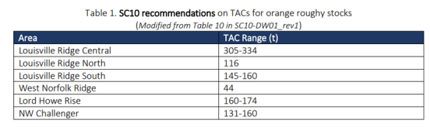

Westpac Bank Allocation

Catch allocation for Westpac Bank was set at the 2025 Commission meeting for 2025 and 2026, based on a stock assessment for the Challenger Plateau that was presented at the 2024 SC. The Challenger Plateau includes the Westpac Bank and the New Zealand domestic area designated - ORH 7A as depicted on the map below:

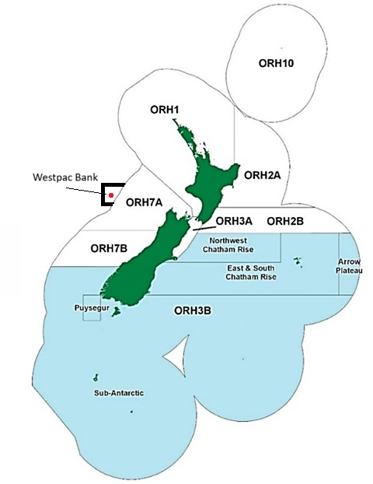

The 2025 SC recommended that “no changes are made to the Westpac Bank TAC until the stock structure work is presented in 2026. However, further bilateral discussions since then have taken place in relation to papers on orange rough genetics, including a 2013 paper (link) by Varela, Ritchie and Smith, that have helped to provide further evidence that there is a high likelihood that the orange roughy population in Westpac Bank and New Zealand’s EEZ in area ORH 7A (see map below) is a straddling stock. The paper concludes:

In the present study we found high levels of microsatellite DNA diversity in orange roughy populations, which likely reflect large historical population sizes. Significant genetic population structure was detected at the global scale, with the highest values of differentiation between the Northeast Atlantic Ocean and the Southern hemisphere regions; however, no significant divergence was found between New Zealand and Australia. A pattern of IBD at the global scale suggests stepping-stone migration, which is probably mediated by the dispersal of long-lived adults. Our results provide new information about the global levels of genetic divergence in this commercially important and widely distributed deep-sea fish.

Given this, New Zealand is proposing that the allocation for Westpac Bank is also set for the 2026-2028 period, in order to align with the dates for the other areas. No new stock assessments are due to be undertaken for the Challenger Plateau (which includes Westpac Bank) until after 2028 and the current allocation is highly precautionary.

Has the proposal financial impacts or influence on the Secretariat work? |  | ☐ Yes ☒ No
To be filled out by the Secretariat:
Ref: COMM14-Prop08 | Received on: 11 January 2026

CMM 03a-2026
Conservation and Management Measure for Deepwater Species
in the SPRFMO Convention Area
(Supersedes CMM 03a-2025)

The Commission of the South Pacific Regional Fisheries Management Organisation;
ADOPTS the following Conservation and Management Measure (CMM) in accordance with Articles 8, 20, 21 and 22 of the Convention:

Objective
- The objective of this CMM together with CMM 03-2026 (Bottom Fishing) is, through the application of the precautionary approach and an ecosystem approach to fisheries management, to ensure the long-term conservation and sustainable use of deep sea fishery resources, including target fish stocks as well as non-target or associated and dependent species, and, in doing so, to safeguard the marine ecosystems in which these resources occur, including inter alia the prevention of significant adverse impacts on vulnerable marine ecosystems.

Interpretation
- For the purposes of this CMM, the definitions applicable in CMM 03-2026 (Bottom Fishing) have the same meaning in this CMM.
- For the purposes of this CMM, nine orange roughy ‘Fishery Management Areas’ are established: Northwest Challenger, North Lord Howe Rise, Central Lord Howe Rise, West Norfolk, Three Kings, South Tasman Rise, North Louisville, Central Louisville and South Louisville. The coordinates and a map are provided in Annex 1.

Application
- All activities conducted under this CMM must be conducted in accordance with CMM 03-2026 (Bottom Fishing).
- This CMM together with CMM 03-2025 (Bottom Fishing) are adopted as cautious preliminary conservation and management measures consistent with Article 22(1) of the Convention.

Catch Limits and Monitoring for Deep Sea Fish Stocks
- The following precautionary catch limits are set by the Commission on the basis of the advice of the Scientific Committee:
- The total catch of orange roughy (Hoplostethus atlanticus) in the Louisville Ridge in the 2026, 2027, 2028 fishing years shall be limited to 581 tonnes in each fishing year as follows.
  - 305 tonnes for the Central Louisville stock;
  - 116 tonnes for the North Louisville stock;
  - 160 tonnes for the South Louisville stock.
- The total catch of orange roughy in the Tasman Sea in the 2026, 2027, 2028 fishing years shall be limited to 378 tonnes in each fishing year as follows.
  - 160 tonnes for the Northwest Challenger stock;
  - 174 tonnes for the Lord Howe Rise stock;
  - 44 tonnes for the West Norfolk Ridge stock.
- Members and CNCPs agree, having regard to the Scientific Committee’s advice, that the total catch of orange roughy throughout its range in the South Tasman Rise should not exceed 0 tonnes.
- The total catch of orange roughy in the portion of the South Tasman Rise occurring in the Convention Area shall be 0 tonnes, until otherwise decided by the Commission, based on advice from the Scientific Committee.
- Consistent with the report of the 12th meeting of the Scientific Committee, Members and CNCPs acknowledged that to maintain the Southwest Challenger Plateau orange roughy stock at or above 34% B₀ for the next five years, the estimated annual yield was calculated to be 942 tonnes.
- The total catch of orange roughy in Westpac Bank shall be limited to 177 tonnes (20% of the Total Allowable Commercial Catch, TACC) in the 2026, 2027 and 2028 fishing years, and New Zealand vessels must account for catch from the Westpac Bank against the TACC for the Southwest Challenger Plateau orange roughy stock.
- Until the Scientific Committee recommends precautionary catch limits, the catch of all other target and non-target fish species in the Evaluated Area shall be limited to a level that does not exceed the annual average catch levels of that Member or CNCP over the period 1 January 2002 to 31 December 2006 as shown in Table 3.
- The Scientific Committee should provide regular advice on the status of bottom fishing target species and non-target species to enable the Commission to continue meeting the objectives of the Convention and this CMM. The Scientific Committee may provide advice on the revision or subdivision of the catch limits set out in this section.
- The Scientific Committee shall review its advice on bottom fishing target species and non-target species no later than every five (5) years, or a shorter period as determined by the Commission. The advice on bottom fishing target species and non-target species, or elements of the advice, may be reviewed together or separately, as determined by the Commission.
- In 2026, 2027, 2028 Members and CNCPs are to share in the total catch of orange roughy, as specified in paragraphs 6, 8 and 10, in the tonnages set out in Table 1 of this CMM.
- Without prejudice to Members and CNCPs without an entitlement in Table 1 and the rights and obligations specified in Article 20(4)(c) of the Convention and having regard to paragraphs 6, 8 and 10, the percentages included in Table 2 shall be used by the Commission as a basis for the allocation of Member and CNCPs’ catch limits from 2026 to 2028 inclusive.
- By 31 December each year, a Member or CNCP may transfer to another Member or CNCP all or part of its entitlement to catch up to the limit set out in Table 1, without prejudice to future agreements on the allocation of fishing opportunities, subject to the approval of the receiving Member or CNCP. When receiving fishing entitlement by transfer, a Member or CNCP may allocate it on the basis of domestic legislation. Before the transferred fishing takes place, the transferring Member or CNCP shall notify the transfer to the Executive Secretary for circulation to Members and CNCPs without delay. Such transfers shall only occur within, and not across, the catch limits and areas defined in paragraphs 6, 8 and 10.
- Where a Member or CNCP has reached 70% of their limit set out in Table 1, that Member or CNCP shall monitor catch daily and ensure there is no further fishing effort by fishing vessels flying its flag once the catch limit has been reached. Members and CNCPs shall notify the Secretariat as soon as practicable of the catch limit being reached.
- For the stocks referred to in paragraph 6(b)(i) and paragraph 6(b)(ii), in addition to the requirements of paragraph 17:
- Members and CNCPs shall monitor and report catch weekly to the Secretariat. Such reporting shall specify catch per stock;
- Where 50% of the catch limit of either of those stocks has been reached, the Secretariat shall notify all Members and CNCPs as soon as practicable and Members and CNCPs shall monitor and report catch daily to the Secretariat for the stock concerned;
- Where 65% of the catch limit for either of those stocks has been reached, the Secretariat shall notify all Members and CNCPs as soon as practicable and Members and CNCPs shall ensure that within 24 hours of receiving notification there is no further fishing effort by fishing vessels flying its flag for that stock for the remainder of the fishing year;
- Where 90% of the catch limit of either of those stocks has been reached prior to the 24 hour notification to cease effort, Members and CNCPs shall ensure that within 4 hours of receiving notification there is no further fishing effort by fishing vessels flying its flag for that stock for the remainder of the fishing year.
- For the stock referred to in paragraph 6(b)(iii), in addition to the requirements of paragraph 17:
- Members and CNCPs shall monitor and report catch daily to the Secretariat;
- Where 50% of the catch limit for that stock has been reached, the Secretariat shall notify Members and CNCPs as soon as practicable, and Members and CNCPs shall ensure that within 24 hours of receiving notification there is no further fishing effort by fishing vessels flying its flag for that stock for the remainder of the fishing year;
- Where 65% of the catch limit of that stock has been reached prior to the 24 hour notification to cease effort, Members and CNCPs shall ensure that within 4 hours of receiving notification there is no further fishing effort by fishing vessels flying its flag for that stock for the remainder of the fishing year.
- If a Member or CNCP’s catch is below their allocated or revised catch limit for orange roughy in an area for which a catch limit has been set in a given year, that Member or CNCP may carry forward the undercatch amount. The total carry forward amount shall not exceed 100% of their allocated catch limit from the year/prior. Members will notify the Secretariat when the catch limit has been fully caught and that they intend to begin fishing the carry forward allocation.
- If a Member or CNCP has exceeded their allocated or revised catch limit for orange roughy in an area for which a catch limit has been set in a given year, the full amount of their catch above the allocated or revised catch limit (whichever results in a greater deduction) shall be deducted from their allocated catch limit for the following fishing year.
- Unless otherwise notified by Members or CNCPs to the Secretariat by 10 December each year, under caught orange roughy allocation will automatically be carried forward to the following year’s allocation for all areas. Members and CNCPs shall notify the Secretariat if they have excess orange roughy catch for a defined area to confirm the revised catch limit for the next fishing year.
- As soon as practicable following the annual meeting of the Commission, Members and CNCPs shall notify the Secretariat of any revised catch limits. The Secretariat shall circulate notifications to all Members and CNCPs, and reflect revised catch limits in monthly catch reports.
- If, on the basis of advice from the Scientific Committee, the Commission agrees to reduce the total catch for an area, the carry-forward provision in paragraph 20 shall not apply, unless decided otherwise by the Commission. The overcatch provision, specified in paragraph 21, shall still apply.
- If the Commission agrees to reduce the orange roughy catch limit of one or more Members or CNCPs for an area for which a catch limit has been set, the carry forward provision in paragraph 20 shall not apply unless decided otherwise by the Commission, taking into account the circumstances of the reduction. The overcatch provision, specified in paragraph 21, shall still apply.
- For the purposes of monitoring catch levels, catches shall be attributed to the flag State of the vessels that have undertaken the fishing described in Article 1(1)(g)(i) and (ii) of the Convention.
- Members and CNCPs shall notify the Secretariat no less than 72 hours in advance of commencing fishing activities if their flagged vessels intend to fish in the Tasman Sea or Westpac Bank areas.
- Members and CNCPs shall report, in an electronic format, the monthly catches of their flagged vessels participating in bottom fishing to the Secretariat within 20 days of the end of each month, consistent with the SPRFMO Data submission templates.
- For the stocks referred to in paragraph 6(b)(i) and paragraph 6(b)(ii), Members and CNCPs shall report, in an electronic format, the weekly catches of their flagged vessels participating in bottom fishing to the Secretariat by 1pm Monday (NZST) each week that catch is recorded, consistent with the SPRFMO Data submission templates. Following notification by the Secretariat that 65% of the catch limit for a stock has been reached, Members and CNCPs shall report, in an electronic format, the daily catches of their flagged vessels participating in bottom fishing to the Secretariat by 1pm (NZST) each day that catch is recorded, consistent with the SPRFMO Data submission templates.
- For the stock referred to in paragraph 6(b)(iii) Members and CNCPs shall report, in an electronic format, the daily catches of their flagged vessels participating in bottom fishing to the Secretariat by 1pm (NZST) each day that catch is recorded, consistent with the SPRFMO Data submission templates.
- The Executive Secretary shall circulate monthly catch reports from data provided in accordance with paragraphs 28, 29 and 30, aggregated by flag State and month, to all Members and CNCPs as soon as possible, once collated.
- The Executive Secretary shall verify the annual catch reports submitted by Members and CNCPs against the submitted data. The Executive Secretary shall inform Members and CNCPs of the outcome of the verification exercise and any possible discrepancies encountered.
- The provisions of this CMM are not necessarily to be considered precedents for future allocation or other decisions in accordance with Article 21 of the Convention relating to participation in bottom fisheries in the Convention Area and adjacent areas of national jurisdiction in the circumstances provided for in Article 20(4)(ii) and (iii) with the consent of the relevant coastal State Member or Members.

Transfer of Allocation
- Australia or New Zealand may transfer between each other (by mutual agreement) all or part of their entitlement to catch up to the limits set out in Table 1 and Table 3, without prejudice to future agreements on the allocation of fishing opportunities. Before the transferred fishing takes place, the transferring Member or CNCP shall notify the transfer to the Executive Secretary for circulation to Members and CNCPs without delay.

Review
- Notwithstanding that the Commission may alter the catch limits prescribed in paragraphs 6, 8 and 10, this CMM shall be reviewed no later than the annual meeting of the Commission in 2026.

Table 1: Tonnages of orange roughy in 2026 2027,2028 as referred to in paragraph 14.
 | Tonnages
 | Australia | New Zealand
Tasman Sea | 76 | 302
Louisville Ridge | 58 | 523
Westpac Bank | 9 | 168
Portion of the South Tasman Rise occurring in the Convention Area | 0 | 0

Table 2: Percentages referred to in paragraph 15 related to the catches of orange roughy referred to in paragraphs 6, 8 and 10.
 | Percentages %
 | Australia | New Zealand
Tasman Sea | 20 | 80
Louisville Ridge | 10 | 90
Westpac Bank | 5 | 95
Portion of the South Tasman Rise occurring in the Convention Area | 75 | 25

Table 3: Tonnages of all other target and non-target fish species in the Evaluated Area as referred to in paragraph 11.
All other target and non-target fish species
Australia | New Zealand
211 | 762

ANNEX 1: Coordinates for Each Fishery Management Area (FMA)
FMA | Point Order | Latitude DDM | Longitude DDM | EEZ Direction
Central Lord Howe Rise | 1 | 35°00.000′S | 164°00.000′E
Central Lord Howe Rise | 2 | 35°00.000′S | 167°00.000′E
Central Lord Howe Rise | 3 | 36°45.000′S | 167°00.000′E
Central Lord Howe Rise | 4 | 36°45.000′S | 164°00.000′E
Central Louisville | 1 | 39°24.000′S | 167°00.000′W
Central Louisville | 2 | 39°24.000′S | 162°30.000′W
Central Louisville | 3 | 43°00.000′S | 162°30.000′W
Central Louisville | 4 | 43°00.000′S | 167°00.000′W
North Lord Howe Rise | 1 | 32°30.000′S | 163°06.980′E | Start on the Australian EEZ
North Lord Howe Rise | 2 | 32°30.000′S | 166°00.000′E
North Lord Howe Rise | 3 | 35°00.000′S | 166°00.000′E
North Lord Howe Rise | 4 | 35°00.000′S | 162°00.000′E
North Lord Howe Rise | 5 | 34°13.064′S | 162°00.000′E | North along the Australian EEZ to the start point
North Louisville | 1 | 35°00.000′S | 172°00.000′W
North Louisville | 2 | 35°00.000′S | 165°00.000′W
North Louisville | 3 | 39°24.000′S | 165°00.000′W
North Louisville | 4 | 39°24.000′S | 167°00.000′W
North Louisville | 5 | 39°30.000′S | 167°00.000′W
North Louisville | 6 | 39°30.000′S | 172°00.000′W
Northwest Challenger | 1 | 36°50.000′S | 166°00.000′E
Northwest Challenger | 2 | 36°50.000′S | 169°28.474′E | South-east along the New Zealand EEZ
Northwest Challenger | 3 | 37°29.902′S | 170°00.000′E | Due south to a point on the New Zealand EEZ
Northwest Challenger | 4 | 37°41.589′S | 170°00.000′E | South-west along the New Zealand EEZ
Northwest Challenger | 5 | 39°30.000′S | 168°08.799′E
Northwest Challenger | 6 | 39°30.000′S | 166°00.000′E
South Louisville | 1 | 41°30.000′S | 162°26.000′W
South Louisville | 2 | 41°30.000′S | 148°00.000′W
South Louisville | 3 | 50°00.000′S | 148°00.000′W
South Louisville | 4 | 50°00.000′S | 162°26.000′W
South Tasman Rise | 1 | 46°25.979′S | 150°00.000′E | Start on the Australian EEZ
South Tasman Rise | 2 | 50°00.000′S | 150°00.000′E
South Tasman Rise | 3 | 50°00.000′S | 145°00.000′E
South Tasman Rise | 4 | 46°55.906′S | 145°00.000′E | East along the Australian EEZ to the start point
Three Kings | 1 | 28°00.000′S | 172°20.000′E
Three Kings | 2 | 28°00.000′S | 175°40.000′E
Three Kings | 3 | 31°00.000′S | 175°40.000′E
Three Kings | 4 | 31°00.000′S | 173°32.686′E | West along the New Zealand EEZ
Three Kings | 5 | 30°47.558′S | 172°20.000′E
West Norfolk | 1 | 34°30.000′S | 168°01.318′E | Start on the New Zealand EEZ
West Norfolk | 2 | 34°30.000′S | 166°30.000′E
West Norfolk | 3 | 32°30.000′S | 166°30.000′E
West Norfolk | 4 | 32°30.000′S | 168°10.000′E
West Norfolk | 5 | 33°19.412′S | 168°10.000′E | South along the New Zealand EEZ to the start point
Westpac Bank | 1 | 39°31.000′S | 166°30.000′E
Westpac Bank | 2 | 39°31.000′S | 168°08.176′E | South-west along the New Zealand EEZ
Westpac Bank | 3 | 40°30.000′S | 167°21.903′E
Westpac Bank | 4 | 40°30.000′S | 166°30.000′E

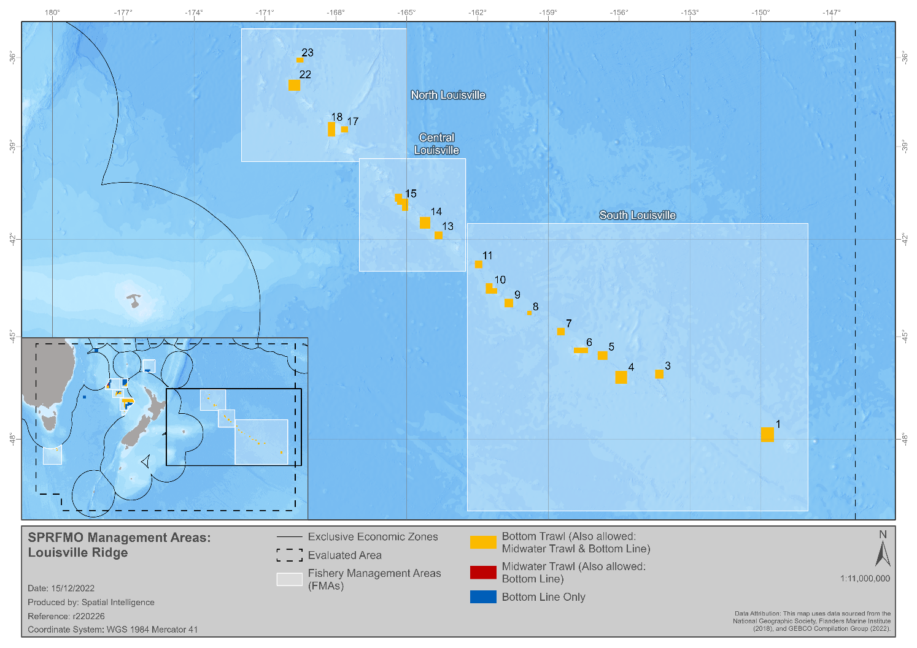

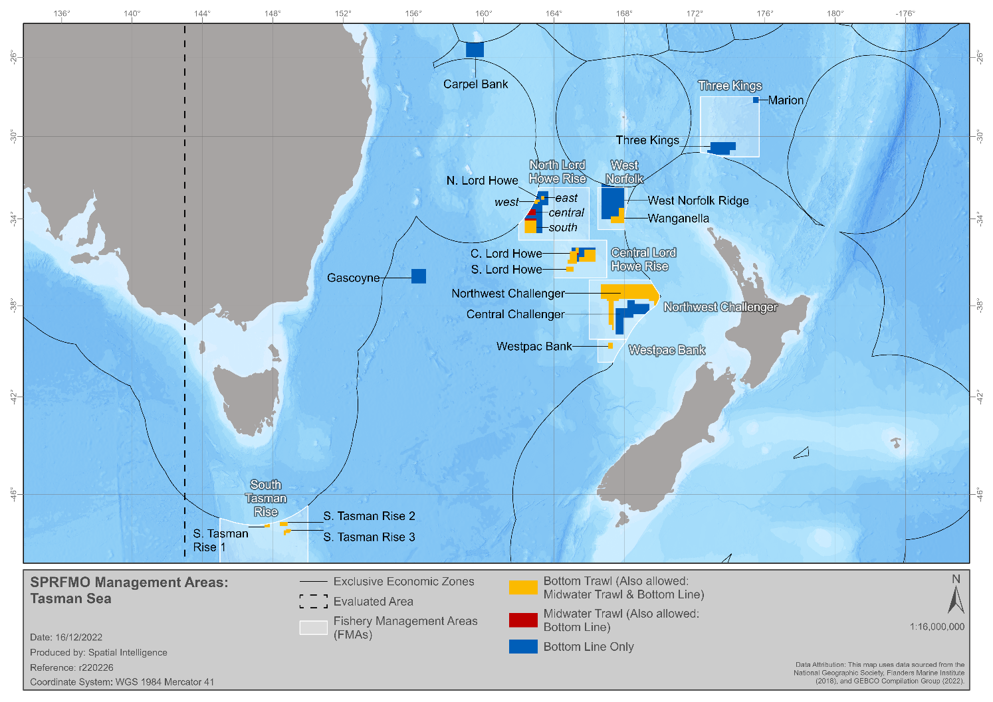

“Louisville Ridge” means all areas within the Evaluated Area to the east of 178ºE.
“Central Louisville stock” means the stock that is located in the “Central Louisville” FMA, as specified in Annex 1.
“North Louisville stock” means the stock that is located in the “North Louisville” FMA, as specified in Annex 1.
“South Louisville stock” means the stock that is located in the “South Louisville” FMA, as specified in Annex 1.
“Tasman Sea” means all areas within the Evaluated Area to the west of 178ºE, excluding the “Westpac Bank” and the “South Tasman Rise”.
“Northwest Challenger stock” means the stock that is located in the “Northwest Challenger” FMA, as specified in Annex 1.
“Lord Howe Rise stock” means the stock that is located in the “N. Lord Howe” and “C. Lord Howe” FMAs, as specified in Annex 1.
“West Norfolk Ridge stock” means the stock that is located in the “West Norfolk Ridge” FMA, as specified in Annex 1.
“South Tasman Rise” means that part of the Australian EEZ and the high seas area adjacent to the Australian EEZ within and bounded by a line beginning at the point of latitude 46˚26’ 07” S, longitude 146˚30 E; and running: (i) from there east along that meridian to its intersection with the meridian of longitude 150˚ 00 E; (ii) from there south along that meridian to its intersection with the parallel of 48˚30 S; and (iii) from there west along that parallel to its intersection with the meridian of longitude 146˚30 E; and (iv) from there north along that meridian to the point where the line began.
“the portion of the South Tasman Rise occurring in the Convention Area” that is located in the “South Tasman Rise” FMA, as specified in Annex 1
“Westpac Bank” means the high seas area adjacent to the New Zealand EEZ that is located in the “Westpac Bank FMA”, as specified in Annex 1.
No tows will begin after the catch limit is reached.
The allocated catch limit is the limit specified in Table 1.
The revised catch limit is the limit determined following the application of the carry forward provision in this paragraph or the overcatch provision in paragraph 21, as applicable.
The undercatch amount is defined as the difference between actual catch and the allocated or revised catch limit (whichever results in lesser carry forward).
Weekly catch is catch taken from 0000hrs Monday New Zealand standard time (NZST) to 2359hrs Sunday (NZST).
Daily catch is catch taken from 0000hrs to 2359hrs each day (NZST).
All or part of carried forward catch can also be transferred to the other Member.
Noting that the tonnages in Table 3 correspond to the evaluated area defined in paragraph 4 of CMM 03-2025 (Bottom fishing).

