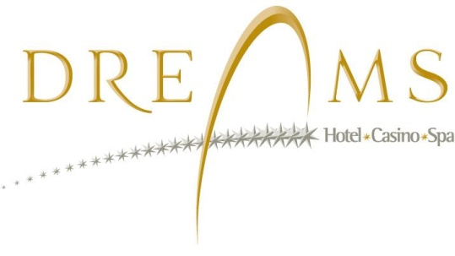RESERVATION REQUEST
SPRFMO MEETINGS
January 20th – January 29th, 2016
HOTEL DREAMS PEDRO DE VALDIVIA - VALDIVIA

Single Standard room $89.000 + IVA / USD 143 + TAX

Double standard room $95.000 + IVA / USD 153 + TAX

Rates include:
- Buffet Breakfast included, served at the restaurant
- Free access to Hydra Spa (swimming pool, sauna & gym)
- Free parking
- Free Wi Fi Internet access
Name of guest:
Passport number:
Phone number: Email address:
Arrival date: Departure date:

Number of guests: Room type:(2 twin beds or one King size bed):
Name of Company:

Contact person: Phone number:
Email address:

Bank account information for advanced deposit
Name of Bank: SANTANDER Account number: 0050767-9
Account holder: PLAZA CASINO S.A. Rut: 96.904.770-5
A deposit or payment transfer receipt should be sent to Vtorresf@mundodreams.com together with this reservation request form, no later than September 21th, 2015

Credit card information:
Number:
Expiration date:
Cardholder´s name:

Hereby, Dreams - Hotel, Casino & Spa is authorized to bill the total cost of lodging on September 21th, 2015, to the credit card

Cardholder´s signature: Date:

CANCELLATION POLICY:
All modifications or cancellations informed after the date of September 21th, 2015 are subject to penalty charges such as the total cost of all nights reserved.
- Must attach a copy of both sides of the credit card in order to process the request.All rate penalties are subject to Contract Agreement stipulated by Servicios Hoteleros y Turisticos S.A.
- Please fill out and return form to vtorresf@mundodreams.com / www.mundodreams.com

