Advice October 2013
Stock: Jack Mackerel (Trachurus murphyi)
Region: SPRFMO convention area, including EEZ of Chile, Peru and Ecuador

Advice for 2014
The SPRFMO Science Committee advises to maintain 2014 catches at or below 440 000t.

Stock status
 |  | 2011 | 2012 | 2013
Fishing mortality in relation to | F_{MSY} | Above | Below | Below
Spawning stock biomass in relation to | B_{MSY} | Below | Below | Below

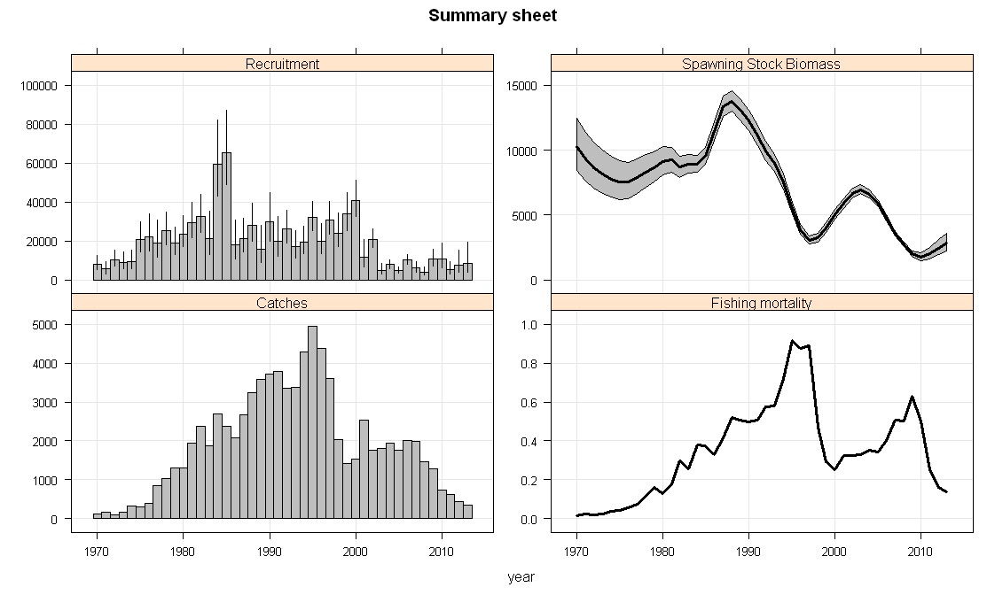Figure 1. Jack Mackerel in the SPRFMO convention area, including the EEZ of Chile, Peru and Ecuador. Summary of stock assessment. Recruitment is measured in thousands, SSB in thousand tonnes, catch in thousand tonnes and harvest (fishing mortality) as a rate per year.

Outlook for 2014
Constant fishing mortality scenarios were explored at 125%, 100%, 75%, 50% and 0% of F₂₀₁₃ = 0.15. Advice is based on maintaining the likelihood of spawning biomass to increase.
Table 1: Summary results for the near term predictions. Note that “B” in all cases represents thousands of t of spawning stock biomass and Bmsy is taken to be 5.5 million t of spawning biomass in all cases.
Recruitment steepness=0.8, recruitment from 2000-2011
Multiplier of  F₂₀₁₃ | B₂₀₁₅ |  |  |  | P(B₂₀₁₅ > B_{msy}) |  |  |  |  |  |  |  | Catch  2014 (kt) |  |  | Catch  2015 (kt)
0.00 | 3,845 |  |  |  | 0% |  |  |  |  |  |  |  | 0 |  |  | 0
0.50 | 3,480 |  |  |  | 0% |  |  |  |  |  |  |  | 230 |  |  | 270
0.75 | 3,316 |  |  |  | 0% |  |  |  |  |  |  |  | 340 |  |  | 380
1.00 | 3,163 |  |  |  | 0% |  |  |  |  |  |  |  | 440 |  |  | 490
1.25 | 3,020 |  |  |  | 0% |  |  |  |  |  |  |  | 540 |  |  | 580
Recruitment steepness =0.65, recruitment from 2000-2011
Multiplier of  F₂₀₁₃ |  | B₂₀₁₅ |  | P(B₂₀₁₅ > B_{msy}) |  |  |  |  |  |  | Catch  2014 (kt) |  |  |  | Catch  2015 (kt)
0.00 |  | 3,802 |  | 0% |  |  |  |  |  |  | 0 |  |  |  | 0
0.50 |  | 3,438 |  | 0% |  |  |  |  |  |  | 230 |  |  |  | 270
0.75 |  | 3,274 |  | 0% |  |  |  |  |  |  | 340 |  |  |  | 380
1.00 |  | 3,122 |  | 0% |  |  |  |  |  |  | 440 |  |  |  | 490
1.25 |  | 2,980 |  | 0% |  |  |  |  |  |  | 540 |  |  |  | 580

Table 2: Advised and reported catch of Jack Mackerel in the South Pacific
Year |  | Advised catch |  | Reported catch
2008 |  | NA |  | 1,471,122
2009 |  | NA |  | 1,283,474
2010 |  |  |  | 726,708
2011 |  |  |  | 605,817
2012 |  |  |  | 417,317
2013 |  | 441,000
2014 |  | 440,000

