JACK MACKEREL BENCHMARK WORKSHOP SCW14

Seattle, 4-8 July 2022

WD02

**CPUE standardization for the offshore fleet taking into account increases in efficiency**

Martin Pastoors, Niels Hintzen

Corresponding author: [mpastoors@pelagicfish.eu](mailto:mpastoors@pelagicfish.eu)

20/06/2022

**Abstract**

Prior to 2018 two offshore CPUE series have been used in the assessment of Jack Mackerel: the standardized Chinese CPUE and the nominal offshore fleet CPUE (EU, Vanuatu, Korea, Russia). During the 2018 benchmark assessment, the nominal offshore CPUE has been converted into a standardized CPUE series, using GLM and GAM modelling. Since 2019, the standardized offshore CPUE also includes data from China.

A description of the data available for the analysis is presented. The final GAM model consists of a number of discrete factors (year, vessel, month and El Nino Effect) and a smoothed interaction between latitude and longitude.

This working document focuses on investigating the impacts of changes in fisheries efficiency on the standardized CPUE. Changes in fishing efficiency are important to take into account when using CPUE series as indicators of abundance. However, fishing efficiency is notoriously difficult to estimate in concrete cases. Therefore, the analysis has focused on exploring the potential consequences of different assumptions on technical efficiency creep of either zero, 2.5% or 5%.

# Introduction

Prior to 2018 two offshore CPUE series have been used in the assessment of Jack Mackerel: the standardized Chinese CPUE and the nominal offshore fleet CPUE (EU, Vanuatu, Korea, Russia). During the 2018 benchmark assessment, the nominal offshore CPUE has been converted into a standardized CPUE series, using GLM and GAM modelling.

Fisheries efficiency creep is notoriously difficult to estimate in concrete cases, as there are many factors that may contribute to increases in efficiency, both in technical developments (gear, filaments, positioning equipment, sonars, echosounders etc) and in social developments (learning, communication, company strategies) that could lead to efficiency creep. Several recent papers have looked estimating generic increases in efficiency. Palomares and Pauly (2019), estimate an annual increase of 2.4%, Rousseau et al. (2019) estimate 2.6%, Eigaard et al. (2014) come to 3.2% and other authors suggest that efficiency creep may be as high as 5% (Galbraith et al 2017, Scherrer and Galbraith, 2020). We explored the effects of efficiency change by evaluating the impacts of 0%, 2%, 2.5%, 3%, 3.5% and 5%.

# Material and methods

Data from EU, Korea, Russia, Vanuatu and China was made available by the SPRFMO secretariat on 8th July 2021. Two vessels were removed from the dataset because of apparent problems with the units used for catch reporting. During 2020, due to the COVID pandemic, only Russia fished for Jack mackerel in the SPRFMO area.

Below, the summary information by year and contracting party is presented for:

* number of vessels participating in the fishery
* number of fishing days
* total catch of jack mackerel
* mean catch per day

vesselcp year nvessels fishingdays catch catch_day  
---------- ------- ---------- ------------- ----------- -----------  
 . . . . . .  
 CHN 2009 13 1,301 117,963 91  
 CHN 2010 9 869 63,606 73  
 CHN 2011 6 591 32,862 56  
 CHN 2012 3 260 13,012 50  
 CHN 2013 2 177 8,329 47  
 CHN 2014 3 304 21,155 70  
 CHN 2015 6 362 29,180 81  
 CHN 2016 2 277 20,208 73  
 CHN 2017 2 165 16,586 101  
 CHN 2018 2 230 24,366 106  
 CHN 2019 2 217 22,706 105  
 CHN (all) . 4,753 369,974 .  
 . . . . . .  
 EU 2008 6 416 71,650 172  
 EU 2009 8 537 90,722 169  
 EU 2010 6 288 31,258 109  
 EU 2011 2 29 1,185 41  
 EU 2013 1 135 10,012 74  
 EU 2014 2 206 20,510 100  
 EU 2015 2 169 28,007 166  
 EU 2016 2 115 11,470 100  
 EU 2017 2 255 27,652 108  
 EU 2019 1 83 11,789 142  
 EU (all) . 2,233 304,254 .  
 . . . . . .  
 KOR 2008 2 224 12,377 55  
 KOR 2009 2 173 13,759 80  
 KOR 2010 2 125 8,183 65  
 KOR 2011 2 205 9,253 45  
 KOR 2012 2 116 5,492 47  
 KOR 2013 1 89 5,267 59  
 KOR 2014 1 77 4,078 53  
 KOR 2015 2 104 5,749 55  
 KOR 2016 2 195 6,430 33  
 KOR 2017 1 31 1,235 40  
 KOR 2018 2 92 3,717 40  
 KOR 2019 2 111 7,444 67  
 KOR (all) . 1,542 82,983 .  
 . . . . . .  
 RUS 2015 1 37 2,524 68  
 RUS 2017 1 51 3,188 63  
 RUS 2019 1 104 9,412 91  
 RUS 2020 1 55 5,245 95  
 RUS (all) . 247 20,370 .  
 . . . . . .  
 VUT 2008 4 705 101,955 145  
 VUT 2009 4 584 80,166 137  
 VUT 2010 4 438 45,934 105  
 VUT 2011 2 169 7,628 45  
 VUT 2012 2 323 16,463 51  
 VUT 2013 2 223 15,526 70  
 VUT 2014 2 233 15,473 66  
 VUT 2015 2 214 21,224 99  
 VUT 2016 1 85 7,385 87  
 VUT (all) . 2,974 311,753 .  
 . . . . . .  
 (all) (all) . 11,749 1,089,333 .

*Table 1: Overview of the number of vessels, fishing days, Jack mackerel catch and catch per day by Contracting Party*

**Haul positions by contracting party and year**

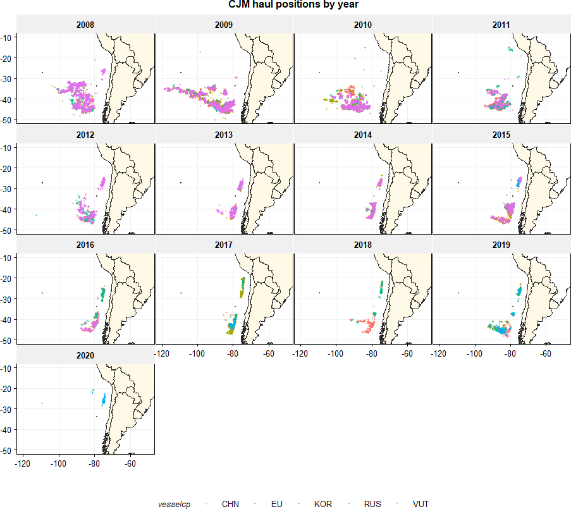

*Figure 1: Haul positions where Jack mackerel has been caught (by year). Colours indicate the different contracting parties*

**Jack mackerel Log CPUE by week and yearly average Log CPUE**

The plot below shows the distributions of log CPUE by week and by contracting party. Log CPUE was calculated as the log of catch per week divided by the number of fishing days per week. The average log CPUE is drawn as a dashed black line. The colours indicate the different individual vessels that generated the CPUE. This shows that the trend in CPUE by individual vessel is largely consistent with the trend in CPUE by contracting party.

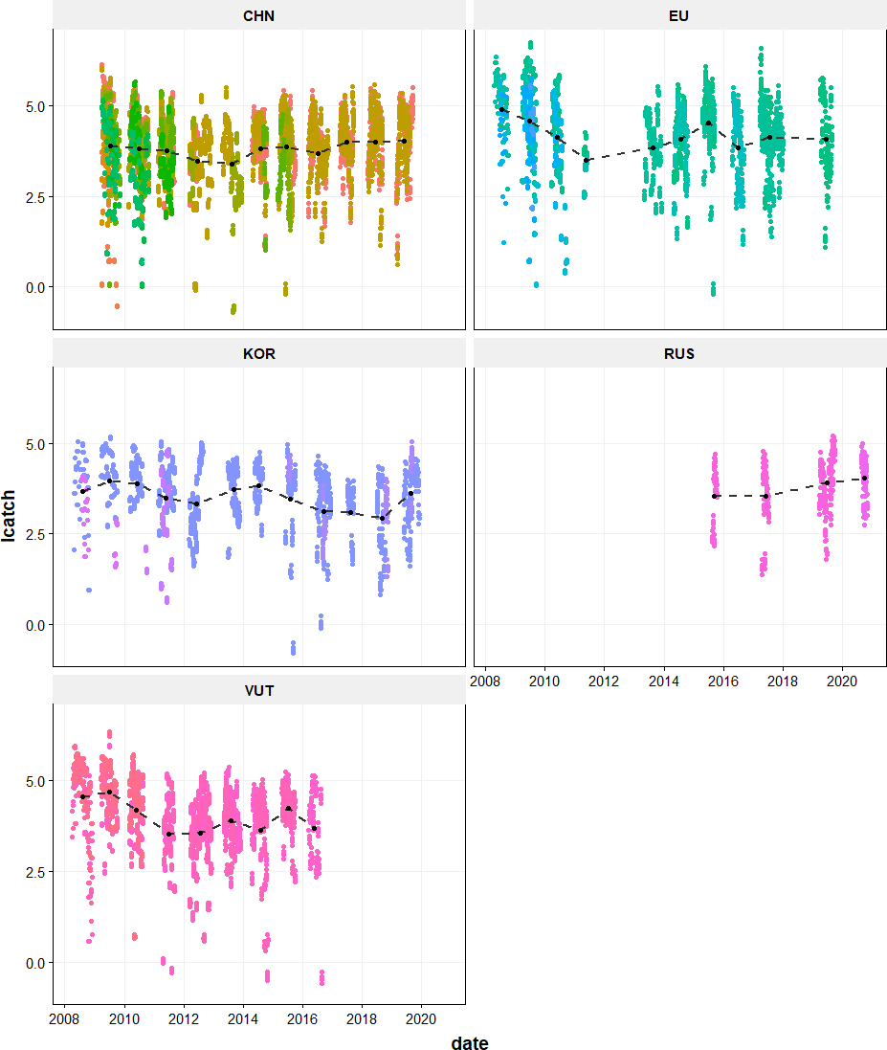

*Figure 2: Jack mackerel log CPUE (log(catch / ndays)) by week.*

**El Nino effect and Humbold_current index**

It has been hypothesized that the catch rate of jack mackerel by area and season could be dependent on the climatic situation, characterized by El Nino events (NOAA, <https://www.esrl.noaa.gov/psd/data/correlation/oni.data>) or the Humboldt Current Index (<http://www.bluewater.cl/HCI/>)

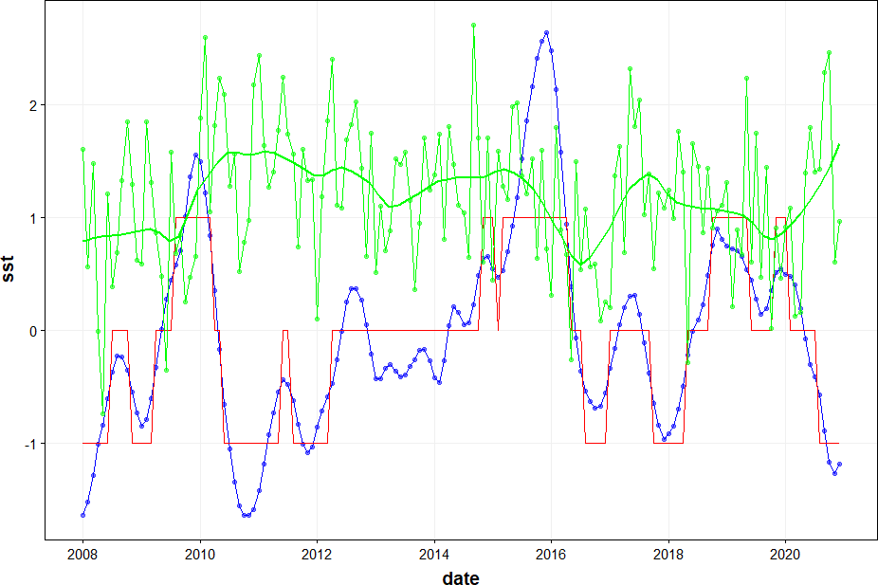

*Figure 3: El Nino temperature anomaly (blue line) and ELE indicator (red line). Humboldt Current Index (green line)*

**Changes in efficiency**

Changes in efficiency were explored in discrete steps of 0%, 2.5% and 5%. Efficiency changes were then incorporated into the measures of fishing effort (number of fishing days per fishing week and per vessel), using the formula:

$$effort=effort*{\left(1+efficiency\right)}^{\left(y-fy\right)}$$

Where $y$ refers to year and $fy$ to the first year in the dataset. The resulting correction factor for fishing effort is shown in the plot below.

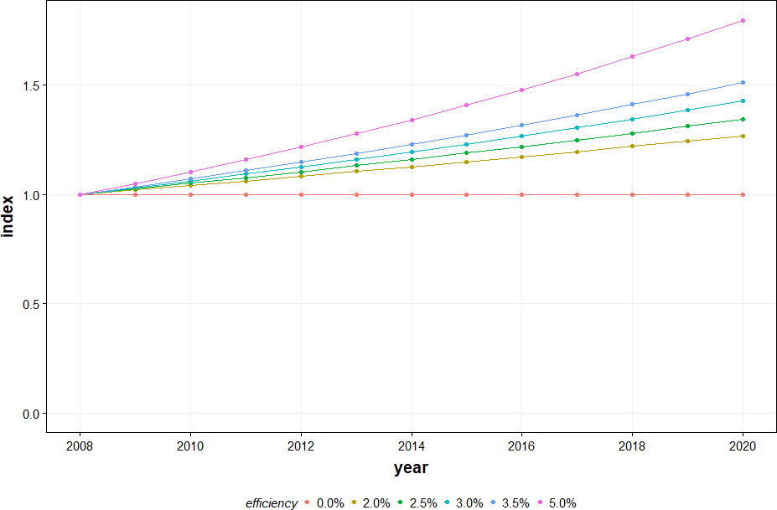

*Figure 4: Impact of efficiency creep on the estimated fishing effort over time*

# Results

During the benchmark assessment 2018 (SCW6), the CPUE standardization method was based on first exploring different factors in a GLM model, and afterwards modelling the spatial interactions with splines in a GAM model. The catch per week is used as the variable to be explained and the log of effort (number of actual fishing days in each week) is used as the offset. The set of explanatory variables has been determined during the 2018 benchmark, using a stepwise approach. During SC9 (2021), a small change was carried through in the explanatory variables whereby the vessel was replace by the contracting party, in order to reduce the degrees of freedom:

First the GLM version of the model:

*GLM: Catch ~ year + vesselcp + month + lat * lon + ELE + offset(log(effort))*

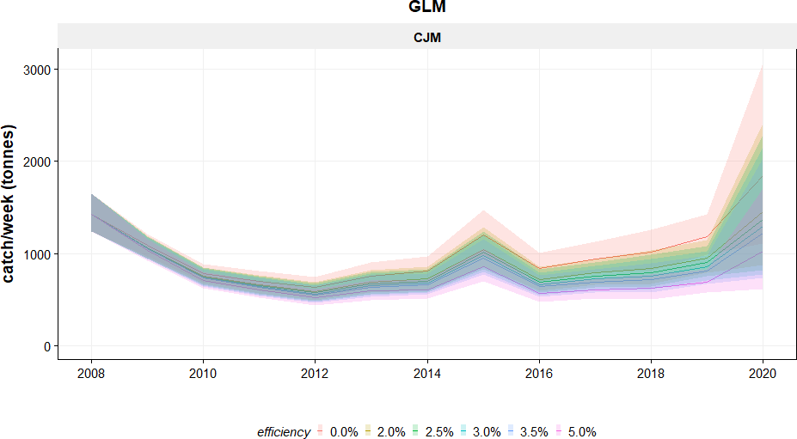 *Figure 5: GLM model results*

**Next the GAM version of the model**

*GAM: Catch ~ year + vesselcp + month + s(lat-lon) + ELE + offset(log(effort))*

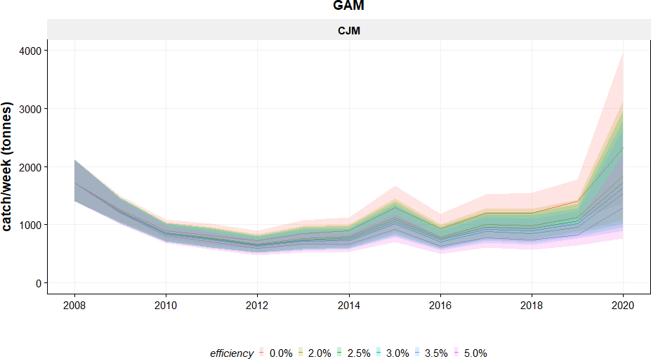

*Figure 6: GAM model results*

**GAM Diagnostics**

**[1] "Efficiency 0.0%"**

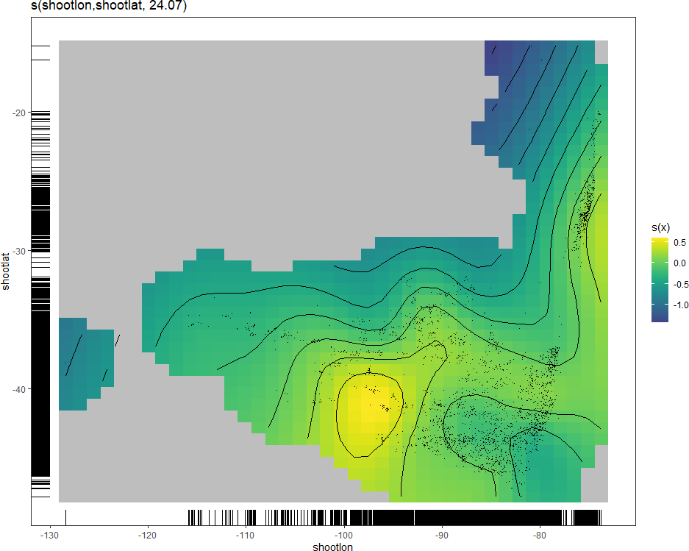

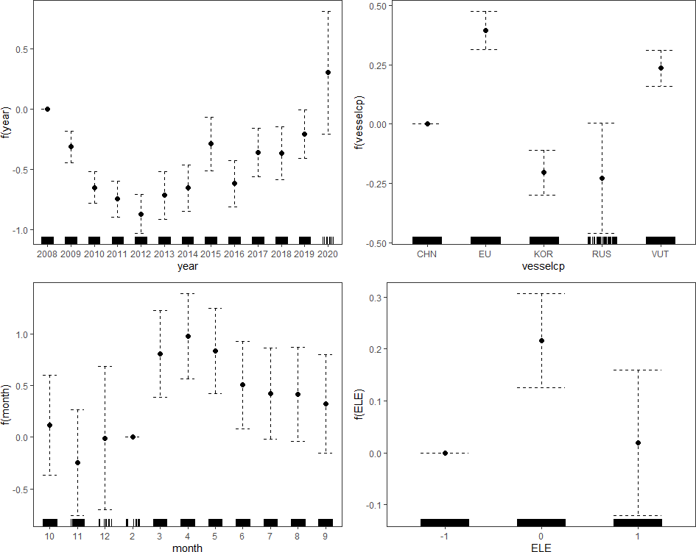

Method: UBRE Optimizer: outer newton  
full convergence after 5 iterations.  
Gradient range [1.144156e-09,1.144156e-09]  
(score 0.09656081 & scale 1).  
Hessian positive definite, eigenvalue range [0.001553249,0.001553249].  
Model rank = 58 / 58   
  
Basis dimension (k) checking results. Low p-value (k-index<1) may  
indicate that k is too low, especially if edf is close to k'.  
  
 k' edf k-index p-value   
s(shootlon,shootlat) 29.0 24.1 0.76 <2e-16 ***  
---  
Signif. codes: 0 '***' 0.001 '**' 0.01 '*' 0.05 '.' 0.1 ' ' 1

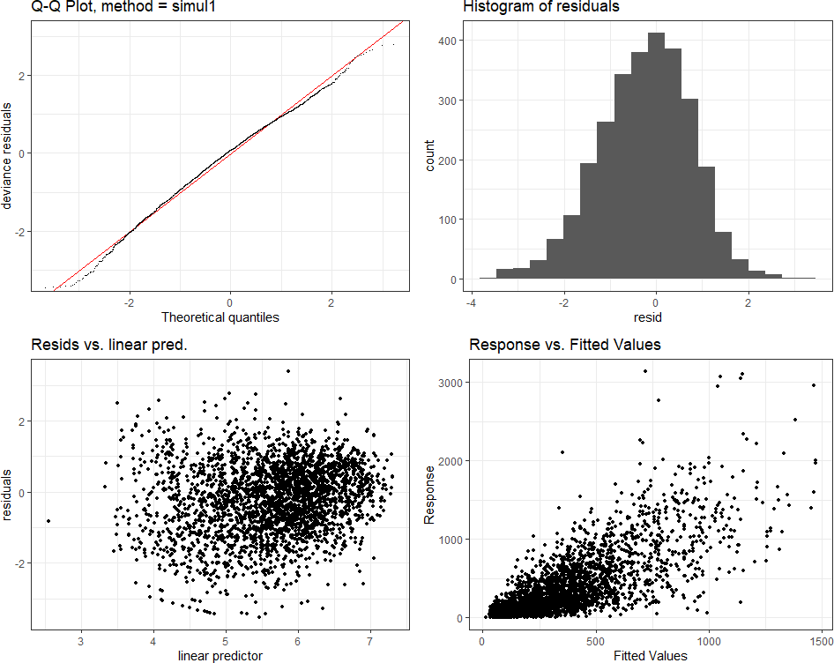

Family: Negative Binomial(1.819)   
Link function: log   
  
Formula:  
catch ~ year + vesselcp + month + s(shootlon, shootlat) + ELE +   
 offset(log(effort))  
  
Parametric Terms:  
 df Chi.sq p-value  
year 12 228.58 < 2e-16  
vesselcp 4 169.35 < 2e-16  
month 10 96.00 3.43e-16  
ELE 2 24.84 4.04e-06  
  
Approximate significance of smooth terms:  
 edf Ref.df Chi.sq p-value  
s(shootlon,shootlat) 24.07 27.62 129.1 <2e-16

**[1] "Efficiency 2.5%"**

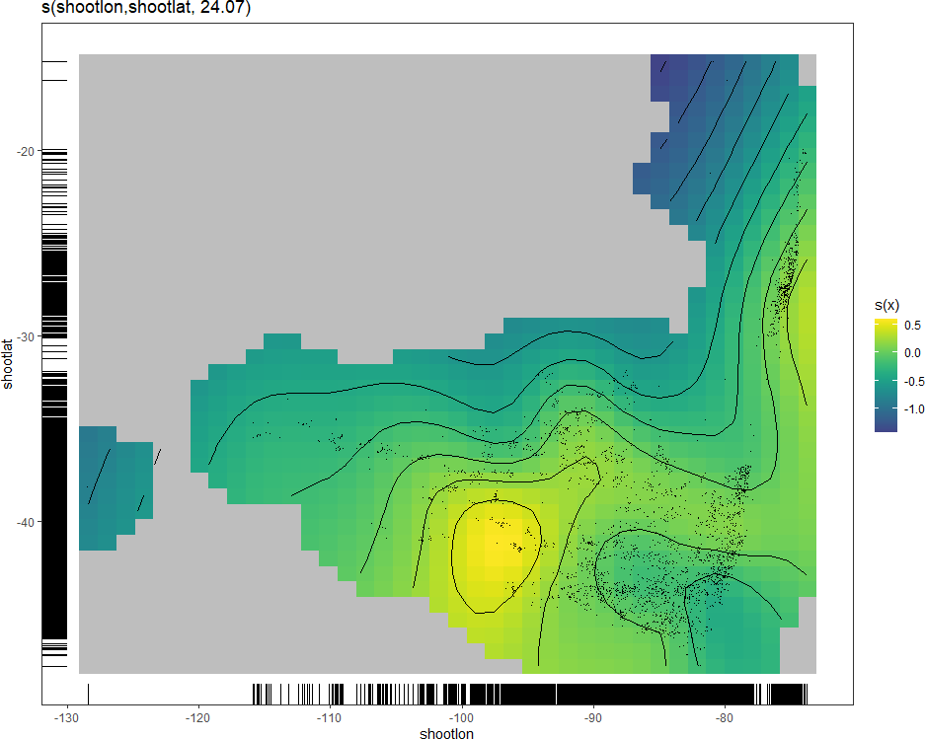

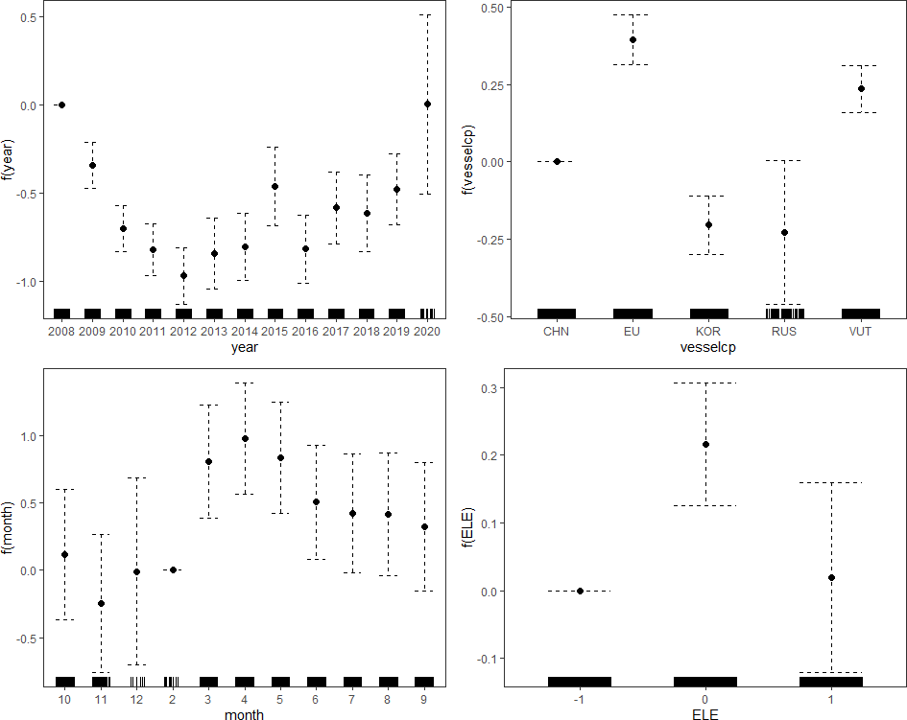

Method: UBRE Optimizer: outer newton  
full convergence after 5 iterations.  
Gradient range [1.144156e-09,1.144156e-09]  
(score 0.09656081 & scale 1).  
Hessian positive definite, eigenvalue range [0.001553249,0.001553249].  
Model rank = 58 / 58   
  
Basis dimension (k) checking results. Low p-value (k-index<1) may  
indicate that k is too low, especially if edf is close to k'.  
  
 k' edf k-index p-value   
s(shootlon,shootlat) 29.0 24.1 0.76 <2e-16 ***  
---  
Signif. codes: 0 '***' 0.001 '**' 0.01 '*' 0.05 '.' 0.1 ' ' 1

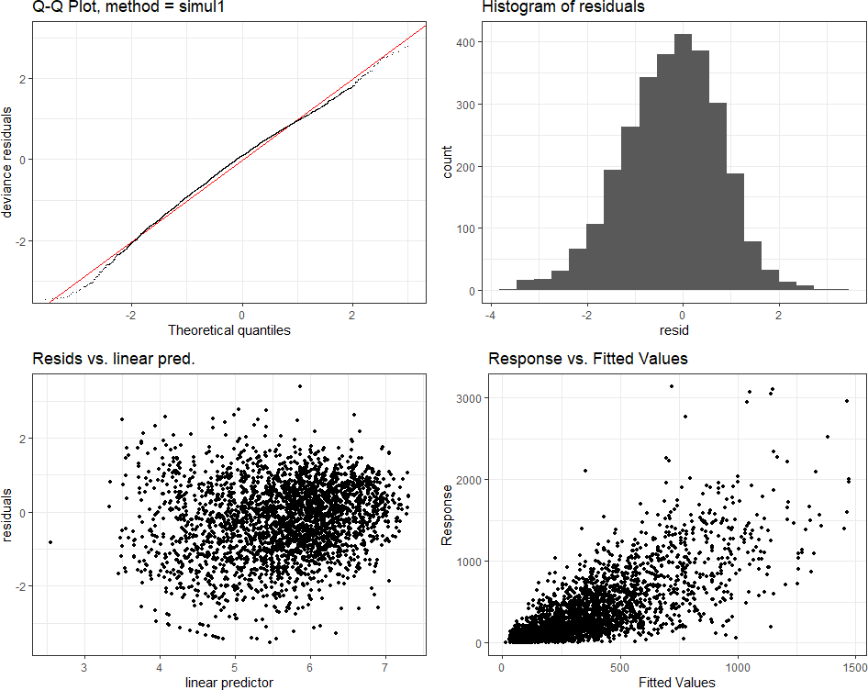

Family: Negative Binomial(1.819)   
Link function: log   
  
Formula:  
catch ~ year + vesselcp + month + s(shootlon, shootlat) + ELE +   
 offset(log(effort))  
  
Parametric Terms:  
 df Chi.sq p-value  
year 12 254.61 < 2e-16  
vesselcp 4 169.35 < 2e-16  
month 10 96.00 3.43e-16  
ELE 2 24.84 4.04e-06  
  
Approximate significance of smooth terms:  
 edf Ref.df Chi.sq p-value  
s(shootlon,shootlat) 24.07 27.62 129.1 <2e-16

**[1] "Efficiency 5.0%"**

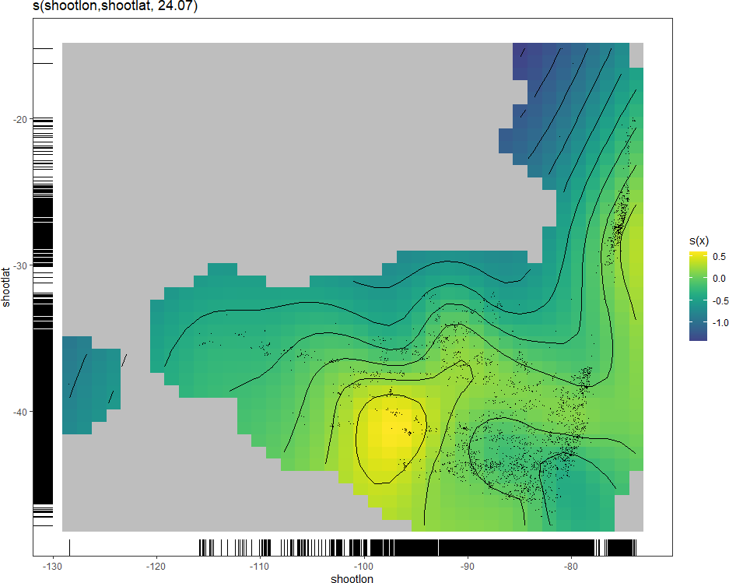

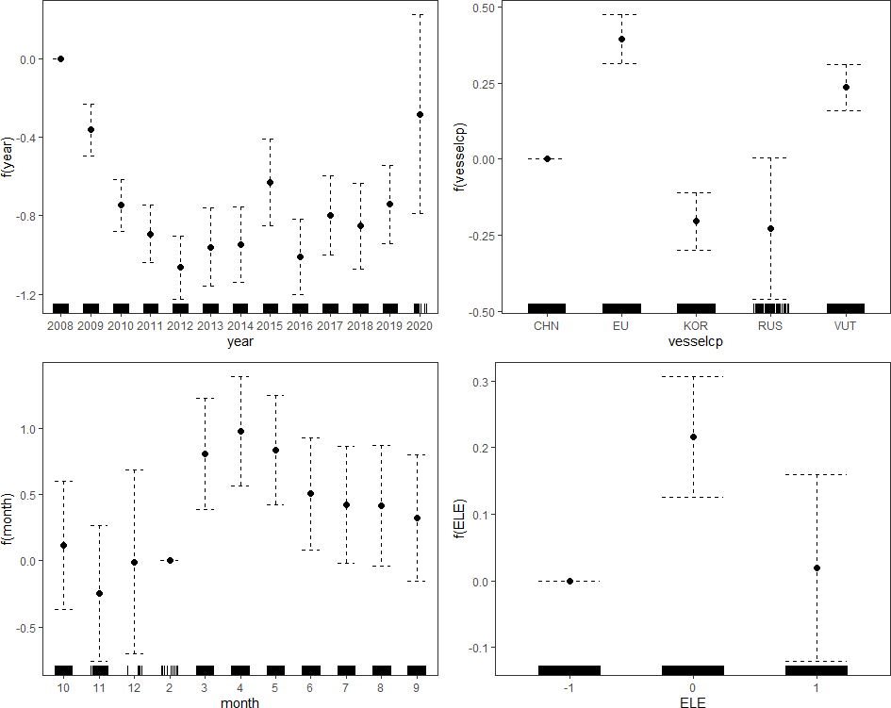

Method: UBRE Optimizer: outer newton  
full convergence after 5 iterations.  
Gradient range [1.144156e-09,1.144156e-09]  
(score 0.09656081 & scale 1).  
Hessian positive definite, eigenvalue range [0.001553249,0.001553249].  
Model rank = 58 / 58   
  
Basis dimension (k) checking results. Low p-value (k-index<1) may  
indicate that k is too low, especially if edf is close to k'.  
  
 k' edf k-index p-value   
s(shootlon,shootlat) 29.0 24.1 0.76 <2e-16 ***  
---  
Signif. codes: 0 '***' 0.001 '**' 0.01 '*' 0.05 '.' 0.1 ' ' 1

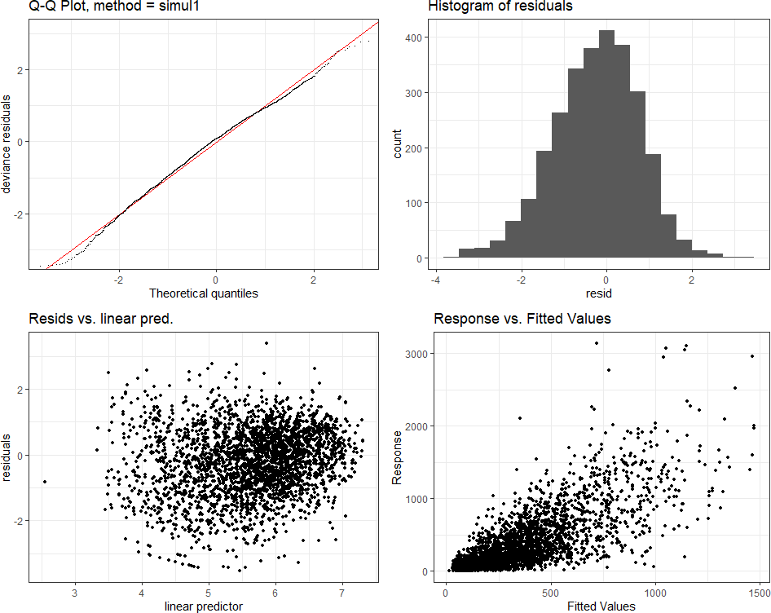

Family: Negative Binomial(1.819)   
Link function: log   
  
Formula:  
catch ~ year + vesselcp + month + s(shootlon, shootlat) + ELE +   
 offset(log(effort))  
  
Parametric Terms:  
 df Chi.sq p-value  
year 12 303.77 < 2e-16  
vesselcp 4 169.35 < 2e-16  
month 10 96.00 3.43e-16  
ELE 2 24.84 4.04e-06  
  
Approximate significance of smooth terms:  
 edf Ref.df Chi.sq p-value  
s(shootlon,shootlat) 24.07 27.62 129.1 <2e-16

*Figure 8:*

*Comparison of standardized CPUE index without and with (2.5%) efficiency creep*

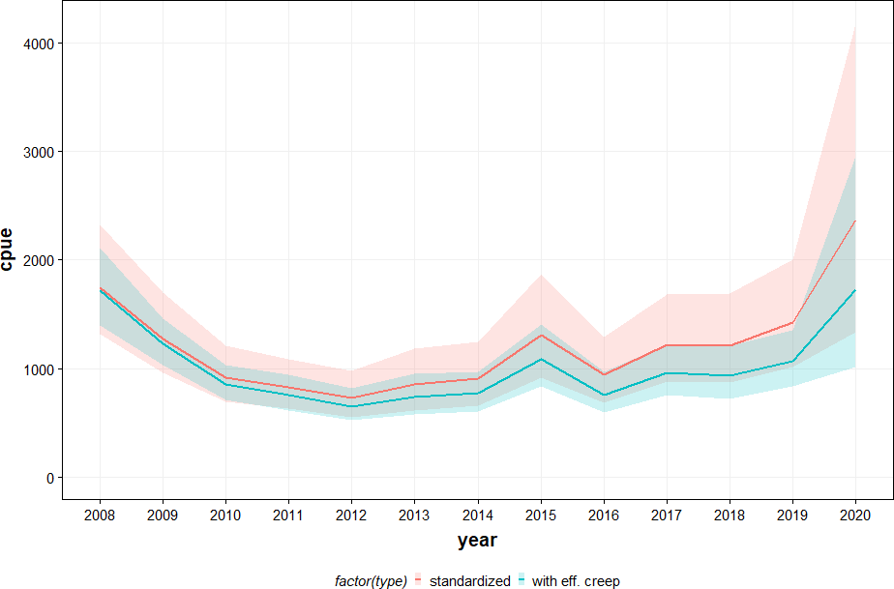

*Table 2: GAM standardized offshore fleet CPUE for jack mackerel*

# Discussion and conclusions

This working document describes the role of efficiency creep on the calculation of a standardized CPUE for the offshore fleets (China, EU, Korea, vanuatu and Russia) based on the haul-by-haul data contained in the SPRFMO database.

The modelling approach has been to use GAM models to assess the dependency on the weekly catch of jack mackerel on different variables. The same explanatory variables have been used as determined during the assessment of 2021. The GAM model consists of catch (per week) as the main variable, the year effect (as factor) as the main explanatory variable and the log of effort as the offset (the log is taken because of the log-link function).

Fisheries efficiency creep cannot be directly estimated in concrete cases like the jack mackerel fishery. There are many factors that may contribute to increases in efficiency, both in technical developments (gear, filaments, positioning equipment, sonars, echosounders etc) and in social developments (learning, communication, company strategies). Several recent papers have provided estimates of generic increases in efficiency at 2.4%, 2.6%, 3.4% and 5%. (Palomares and Pauly, 2019; Rousseau et al., 2019; Eigaard et al., 2014; Galbraith et al, 2017; Scherrer and Galbraith, 2020). We explored the effects of efficiency change by evaluating the impacts of 0%, 2%, 2.5%, 3%, 3.5% and 5%, and selected 2.5% as the base case to be put forward in the 2022 benchmark workshop.

# Acknowledgements

We would like to acknowledge the permission granted by the delegations of China, Russia, Vanuatu and Korea to utilize their haul-by-haul data for the analysis of standardized CPUE of the offshore fleet fishing for Jack mackerel. Sharing access to vessel data has made it possible to improve the indicator that can be used in the assessment.

# References

Galbraith, E. D., D. A. Carozza and D. Bianchi (2017). “A coupled human-Earth model perspective on long-term trends in the global marine fishery.” Nature Communications 8.

Li, G., X. Zou, X. Chen, Y. Zhou and M. Zhang (2013). “Standardization of CPUE for Chilean jack mackerel (Trachurus murphyi) from Chinese trawl fleets in the high seas of the Southeast Pacific Ocean.” Journal of Ocean University of China 12(3): 441-451.

Marchal, P. M., B. Andersen, B. Caillart, O. Eigaard, O. Guyader, H. Hovgaard, A. Iriondo, F. L. Fur, J. Sacchi and M. Santurtun (2007). “Impact of technological creep on fishing effort and fishing mortality, for a selection of European fleets.” ICES journal of marine science 64(1): 192.

Palomares, M. L. D. and D. Pauly (2019). “On the creeping increase of vessels’ fishing power.” Ecology and Society 24(3).

Rousseau, Y., R. A. Watson, J. L. Blanchard and E. A. Fulton (2019). “Evolution of global marine fishing fleets and the response of fished resources.” Proceedings of the National Academy of Sciences 116(25): 12238-12243.

Scherrer, K. J. N. and E. D. Galbraith (2020). “The risk of underestimating long-term fisheries creep.” Ecology and Society 25(1).

SPRFMO (2011) Report of the Jack Mackerel Subgroup. Tenth Science Working Group of SPRFMO, 19 – 23 September 2011, Port Vila, Vanuatu.

SPRFMO (2018) CPUE standardization for the offshore fleet fishing for Jack mackerel in the SPRFMO area (SCW6-Doc05). Sixth Science Committee Workshop, 28-30 May 2018, Valparaiso, Chile.

SPRFMO (2021). Report of the 9th Scientific Committee Meeting, 27 September-3 October 2021.