**SCW14 JM Benchmark workshop**

**Using self-sampled length-distributions for the EU fleet**

Martin Pastoors, 04/07/2022

PFA report 2022_xx / SCW14-JMxx

**Executive summary**

[ summary here ]

# Introduction

This document aims to provide a comparison of the length compositions in the EU fisheries for Jack mackerel, derived from either the EU observer program or the PFA selfsampling program.

The EU observer program has been carried out by Wageningen Marine Research and the Polish Marine Research Institute. It aims to have observers on board for at least 10% of the fishing trips. In practice the coverage is higher than 10% [check]. However, due to the nature of the observer program certain seasons or areas may be missed in the sampling, because no observer is on board during certain trips.

The PFA self-sampling is carried out on all PFA vessels that are fishing in the South Pacific. All trips have been sampled, but in general the sampling frequency is lower than during observer trips.

[ Introduction here ]

[describe how the data have been processed]

EU observer data: Length frequency from file supplied by Niels Sampling meta data read from EU ALK files. Sampling data does not contain information on the number of trips or hauls that have been sampled. Sampled catch refers to the catch of the trips that were observed. No information on the total sample weights.

PFA selfsampling data: processed directly from PFA database. Sampled catch refers to the trips that were selfsampled which is all trips and therefore the same as the total catch.

[ Material and methods here ]

# Results

An overview of the selfsampling metadata is presented in the table below.

year nvessels ntrips ndays nhauls catch catch/day nlength  
------- ---------- -------- ------- -------- --------- ----------- ---------  
   
 2015 2 9 175 376 28,815 165 7,299  
 2016 1 4 93 167 10,284 111 6,803  
 2017 2 10 273 609 29,652 109 20,829  
 2018 1 5 130 236 10,235 79 4,692  
 2019 1 3 85 162 12,115 143 6,264  
 2021 3 10 174 423 43,892 252 18,185  
 2022* 2 7 122 316 26,115 214 19,673  
 (all) 48 1,052 2,289 161,108 83,745

*Table 3.1.1: PFA fisheries in the South Pacific. Self-sampling Summary of number of vessels, trips, days, hauls, catch (tonnes), catch per day and number of fish measured. * denotes incomplete year*

A comparison between EU observer program and PFA selfsampling by year demonstrates that the sampled catch in the observer program is generally between 35 and 40%. The number of samples has been quite variable between years while the number of length measurements has sometimes been higher in the observer program and sometimes in the selfsampling program. During the observer program more length measurements are taken per sample than in the selfsampling program.

variable year pfa wmr prop_wmr  
--------------- ------- --------- -------- ----------  
 sampled catch 2015 27,772 10,095 0.36  
 sampled catch 2016 9,431 3,819 0.4  
 sampled catch 2017 27,643 4,817 0.17  
 sampled catch 2018 9,619 4,120 0.43  
 sampled catch 2019 11,786 5,185 0.44  
 sampled catch 2021 36,445 0 0  
 sampled catch 2022 20,713 0 0  
 sampled catch (all) 143,409 28,036 0.2

variable year pfa wmr prop_wmr  
---------- ------- ------- ----- ----------  
 samples 2015 144 141 0.98  
 samples 2016 140 66 0.47  
 samples 2017 305 100 0.33  
 samples 2018 129 77 0.6  
 samples 2019 147 52 0.35  
 samples 2021 346 0 0  
 samples 2022 247 0 0  
 samples (all) 1,458 436 0.3

variable year pfa wmr prop_wmr  
---------- ------- -------- -------- ----------  
 measured 2015 7,381 17,563 2.38  
 measured 2016 6,042 7,633 1.26  
 measured 2017 19,524 13,843 0.71  
 measured 2018 3,937 7,465 1.9  
 measured 2019 6,032 5,152 0.85  
 measured 2021 14,842 0 0  
 measured 2022 13,259 0 0  
 measured (all) 71,017 51,656 0.73

*Table 4.1.1: PFA fisheries in the South Pacific. Self-sampling Summary of number of vessels, trips, days, hauls, catch (tonnes), catch per day and number of fish measured. * denotes incomplete year*

Overview of the number of length measurements (“measured”), the sampled catch and the number of samples. Rows refer to the different quarters. .

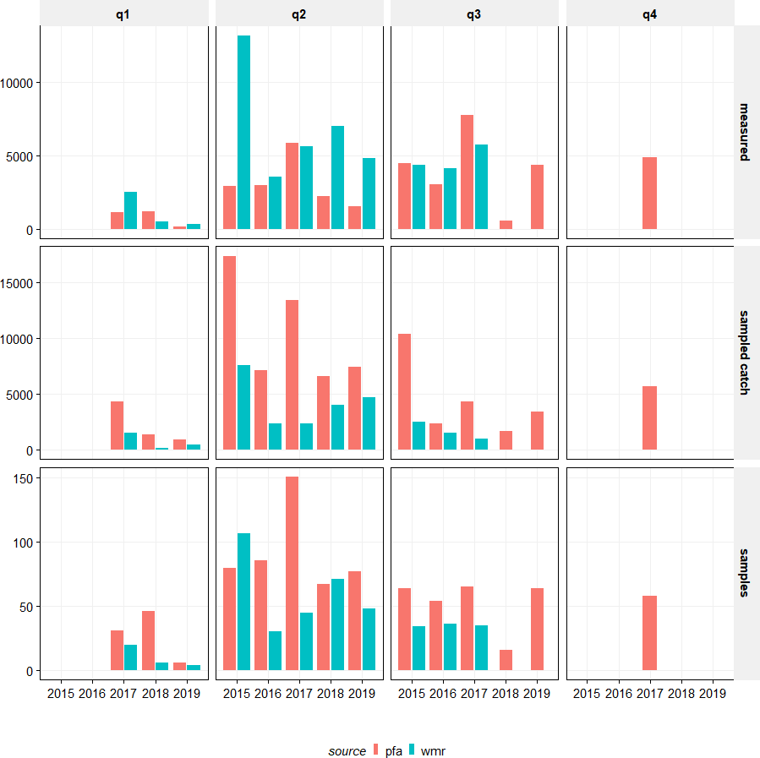

*Table 4.1.2:*

Comparison of the raised catch at length by year and quarter based on the PFA selfsampling and on the WMR observer trips. All catchnumbers raised to the total catch. Several situations may be distinguished:

* nearly full overlap between selfsampling and observer trips (e.g. 2015 Q2, 2017 Q1, 2018 Q2)
* Substantial discrepancies between selfsampling and observer trips (e.g. 2016 Q2, 2017 Q3, 2018 Q1)
* only coverage during self sampling trips (e.g. 2017 Q4, 2019 Q3)
* [not shown] recent year coverage through selfsampling only

Note that the y-axis are scaled indepently of each other.

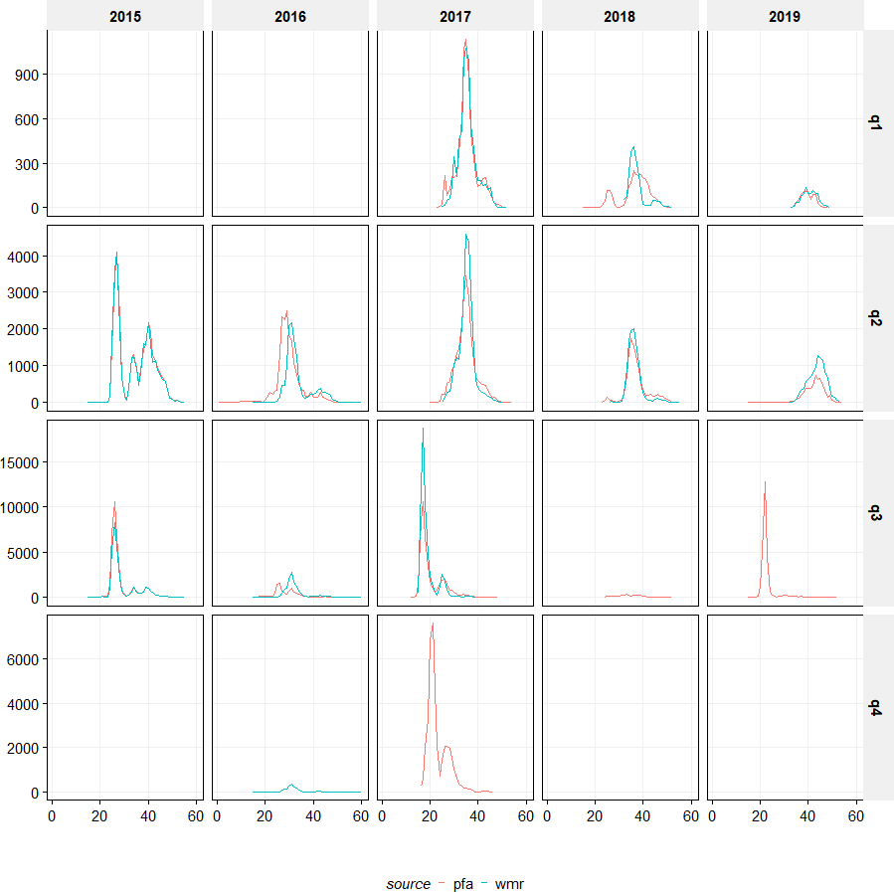

*Table 4.1.2:*