Extending the SPRFMO Jack mackerel assessment model uncertainty estimates

13 July 2022

# 1 Introduction

In this short paper we explore conducting full Bayesian posterior distributions within ADMB using the adnuts R package. For catch advice and uncertainty, the joint Jack mackerel (jjm) assessment model has used point estimates and asymptotic variance estimates to evaluate the uncertainty used for evaluating historical and projected stock trends. Adopting this utility that has recently been added into ADMB provides a robust set of diagnostics. In an extended set of runs we evaluate a time-varying 3-parameter double logistic to evaluate a model with fewer parameters and less reliance on ad-hoc penalty weights applied to the non-parametric approach used previously.

# 2 Methods

## 2.1 Testing Bayesian posterior integrations

A base 2-stock model was selected for testing and evaluating the alternative uncertainty estimates from the 2021 assessment. The code was modified to output a general data frame that could easily be incorporated into R for subsequent processing and testing. Initial model runs using the MCMC routines indicated that some parameters had difficulty mixing. On further investigation, the problem parameters were related to the fishing mortality values in years when there was zero catch reported in the data. Presently, the model can deal with this and just estimates a very small value for predicted catch (in biomass). This succeeds at the maximum likelihood estimates but when sampled randomly, causes poor performance when integrating over the posterior distribution. Adding a small value to the input data where catch was recorded as zero improved the performance of the MCMC routine greatly and made integration of the 1,474 parameters finish to completion in under five minutes.

After evaluating the posterior distribution, we were interested to show how the marginal estimates of uncertainty compare with their asymptotic counterparts (as approximated by the inverse Hessian matrix).

## 2.2 Development of a 3-parameter double logistic selectivity curve

In the proposed release of jjm (1.00.00) we developed a new parametric selectivity form. This was an attempt to reduce the number of parameters in the model while still providing enough flexibility as warranted based on the catch-at-age patterns observed for this stock. This differentiable 3-parameter “double logistic” selectivity pattern by year and age (*t,* and *a*) can be written (with time subscripts on RHS dropped for clarity) as:

$$s_{t,a}={\left[1+e^{\frac{-ln\left(19\right)\left(a-γ_{1}\right)}{p_{1}}}\right]}^{-1}\left[1-{\left(1+e^{\frac{-ln\left(19\right)\left(a-γ_{2}\right)}{p_{3}}}\right)}^{-1}\right]{0.95}^{-2}$$

with

$$γ_{1}=p_{1}+p_{2}$$

$$γ_{2}=p_{1}+γ_{1}+p_{3}$$

and

$γ_{1}=$ first (ascending) inflection point of the selectivity function;

$γ_{2}=$ second (descending) inflection point of the selectivity function;

$p_{1}=$ distance between first inflection point and age at 95% selection;

$p_{2}=$ parameter to be used with p1 to get first inflection point of the selectivity function; and

$p_{3}=$ second slope of the selectivity function.

In this setup, the model implementation was similar to the non-parametric form where the control file expects the following initial vector

3 #Selectivity option (1=non-parametric, 2=logistic, 3=double logistic)  
9 #Number of selected ages  
2 #phase of estimation  
37 #Number of years where selectivity parameters can change

For the 3-parameter double logistic selectivity options, if the number of years allowing for a change is > 0, then vectors specifying the years change can occur is specified, followed by the “allowed” variability (in log space) of the change (like a CV), as with the other options. E.g.,

#Years where selectivity parameters can change  
1984 1985 1986 1987 1988 1989 1990 1991 1992 1993 1994 1995 1996 1997 1998 1999 2000 2001 2002 2003 2004 2005 2006 2007 2008 2009 2010 2011 2012 2013 2014 2015 2016 2017 2018 2019 2020   
# CV of change by year  
0.5 0.5 0.5 0.5 0.5 0.5 0.5 0.5 0.5 0.5 0.5 0.5 0.5 0.5 0.5 0.5 0.5 0.5 0.5 0.5 0.5 0.5 0.5 0.5 0.5 0.5 0.5 0.5 0.5 0.5 0.5 0.5 0.5 0.5 0.5 0.5 0.5

For initial testing, parameter variability was specified to be the same as in the non-parametric form (noting that the latter used age-specific coefficients to describe selectivity patterns by fishery; Butterworth et al. 2003).

# 3 Results and discussion

## 3.1 MCMC sampling using adnuts R package

The posterior sampling commands and results are shown below. Results show that the parameters that were the slowest to mix during the MCMC sampling were well converged nonetheless (Fig. 3.1). The box below shows the general steps (in R) of executing a model set up in a “test” directory.

# Model name  
m <- './jjms'  
# Directory   
d <- 'test'  
#setwd(d)  
#system(paste(m, '-nox -iprint 200 -hbf 1'))  
#setwd('..')  
iter <- 2000 # with 8 cores/chains...  
chains=8  
# *not run*  
#fit.mle <- sample_nuts(model=m, path=d, iter=iter, warmup=iter/4,   
# chains=chains, cores=chains, control=list(adapt_delta=.9,metric='mle'))  
#saveRDS(fit.mle,"test/fit.mle.RDS")  
# Load run  
fit.mle <- readRDS(here("fit.mle.RDS"))  
adnuts::pairs_admb(fit.mle, pars=1:6, order='slow')

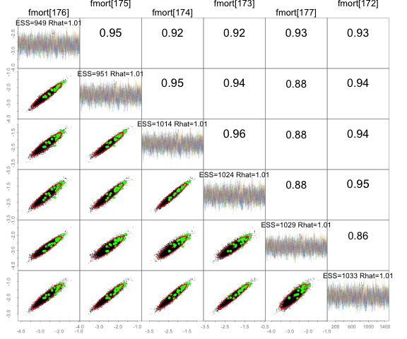

Figure 3.1: Results from the jjm model run with the adnuts package showing the six slowest mixing parameters.

Based on diagnostic plots on MCMC sampling, executing the following command:

adnuts::plot_sampler_params(fit.mle)

shows favorable mixing and that the posterior is reasonably represented (Fig. 3.2). For Jack mackerel, we rely on asymptotic approximations to the uncertainty in estimates. Consequently, comparing these to the marginal standard errors of estimates from the MCMC sampling of the posterior distribution is useful. A plot from the package command:

adnuts::plot_uncertainties(fit.mle)

shows good similarity between the asymptotic approximation and the full marginal distribution (Fig. 3.3).

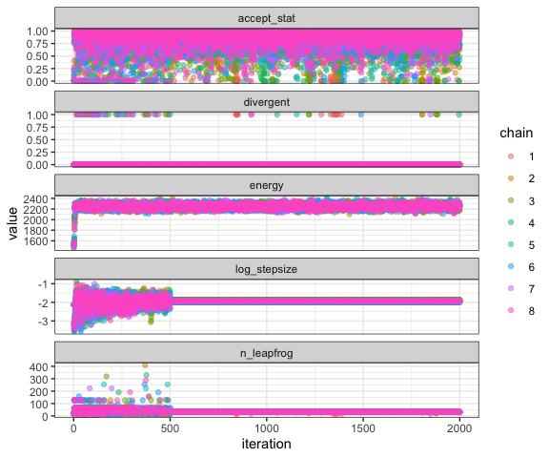

Figure 3.2: Results from the jjm model run with the adnuts package showing sampling conditions.

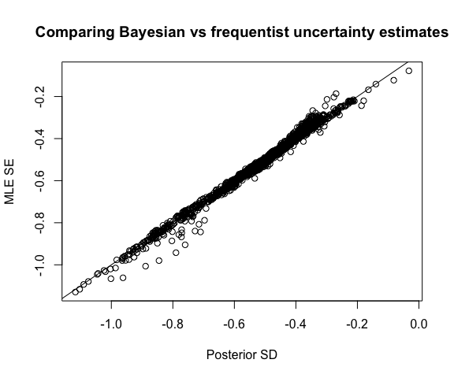

Figure 3.3: Results from jjm model run comparing the log standard errors from the asymptotic estimates compared to the approximated marginal values from the MCMC posterior distribution.

Note that for further diagnostics, a library of attributes can be accessed via:.

launch_shinyadmb(fit.mle).

The jjm model is flexible in what can be saved as part of the MCMC output. Currently it is configured to show the distribution of quantities of management interest, e.g., spawning biomass in the last year. Such quantities also include the component parts of the posterior likelihood. To illustrate, we show how the posterior samples relate to each of the information components (in negative log-likelihood units). By subtracting off the mean value within each component we show how different data and prior components change for different spawning biomass levels (Fig. 3.4). This approach could be considered as another way to evaluate different data component impacts on quantities of interest (akin to previously performed profiles of scale, aka “Piner plots”).

The time series of spawning biomass estimates from the MCMC shows broad confidence bounds and similar projections can be evaluated given different catch projection scenarios (Fig. 3.5).

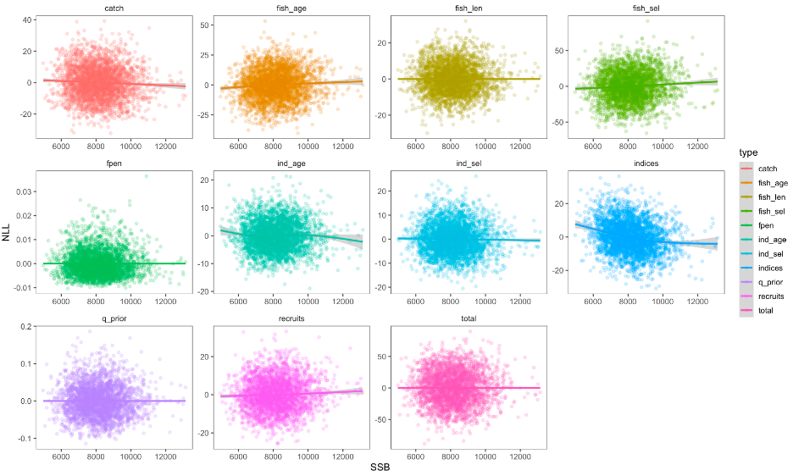

Figure 3.4: Results from the jjm model run with the adnuts package showing the component negative log-likelihood values given the spawning biomass (SSB) at the end of the model period.

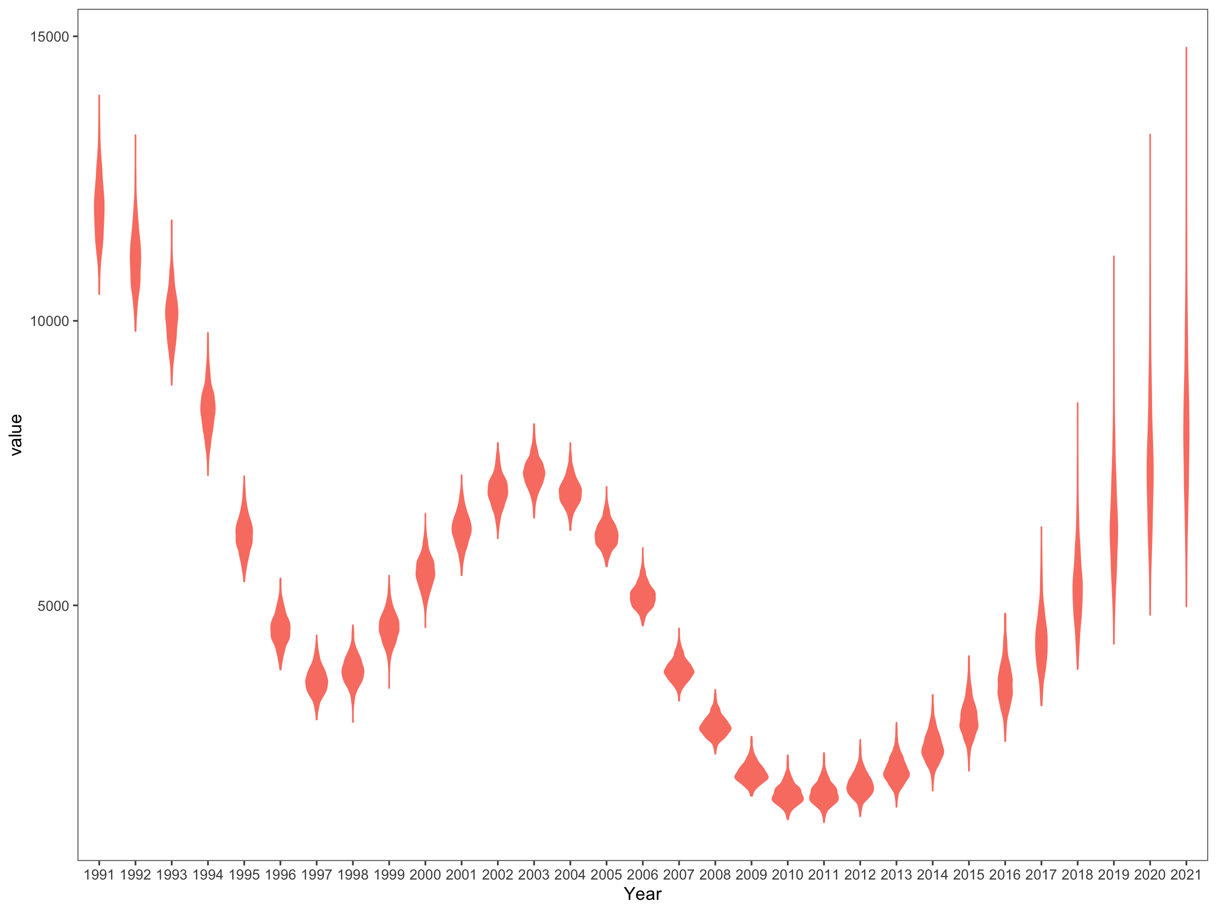

Figure 3.5: Spawning biomass for Jack Mackerel based on the posterior distribution from the jjm model with the adnuts package

## 3.2 Testing an alternative selectivity function form

In the proposed release of jjm (1.00.00), the new 3-parameter double logistic (with time-varying component) selectivity option provided less flexibility than the standard plots, but patterns were broadly similar (Fig. 3.6). However, initial tests of doing the MCMC integration resulted in more work needed for resolving some of the parameters.

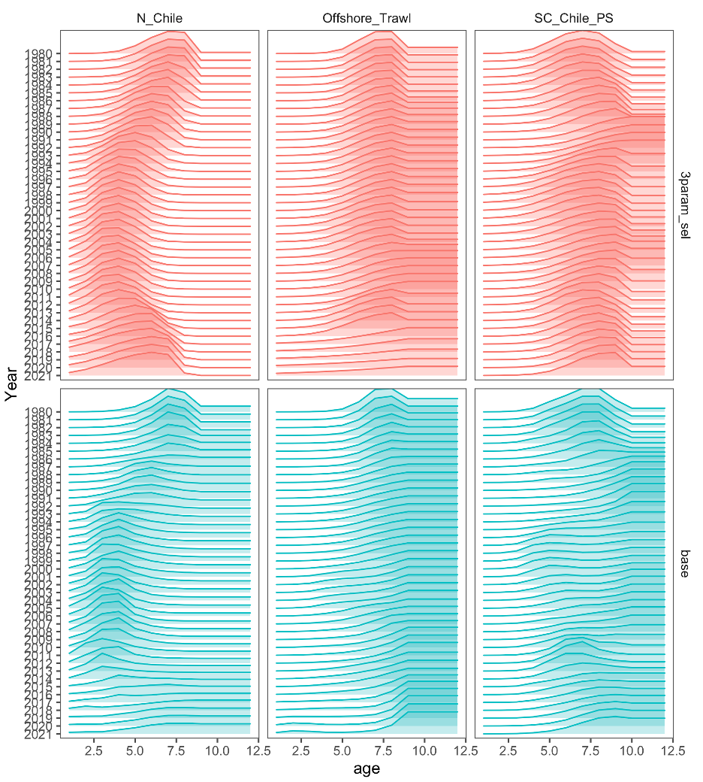

Figure 3.6: Selectivity for three main fisheries (columns) over time using the base (default) model (bottom row) and using the new 3-parameter double logistic (top row).

## Acknowledgements

Cole Monnahan assisted with conducting and interpreting the application of the adnuts R package.

# 4 References

Butterworth, D.S, J. N. Ianelli & R. Hilborn (2003) A Statistical Model for Stock Assessment of Southern Bluefin Tuna with Temporal Changes in Selectivity, African Journal of Marine Science, 25:1, 331-361, DOI: 10.2989/18142320309504021.

Monnahan CC, Kristensen K (2018). “No-U-turn sampling for fast Bayesian inference in ADMB and TMB: Introducing the adnuts and tmbstan R packages.” PLoS ONE, 13(5), e0197954.

Monnahan CC (2018). adnuts: No-U-Turn MCMC Sampling for ADMB Models. . R package version 1.1.2.