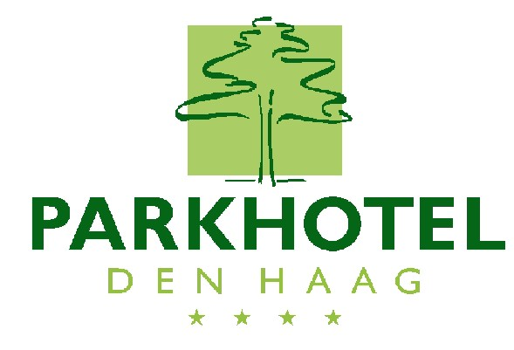
Molenstraat 53
2513 BJ Den Haag
Holland

Tel. 070 362 43 71
Fax 070 361 45 25
E-mail: info@parkhoteldenhaag.nl

Bank
ABN Amro: 630.497.869

REPLY FORM

Allot. Code: 47915

The Parkhotel Den Haag has reserved a number of rooms for October 6th -16th 2016.
To make a reservation we ask you to fill out this form and return it before the July 1st 2016.

When you would like to make a reservation after this date, we will handle your request on availability. Incase the room type is booked we have to reserve an other room type and rate for you!

We ask you to fill out the following details:

Arrival : ____________
Departure : ____________

Room : 1 Budget single room € 109.00
Room : 1 Superior room for single use € 139.00
Room : 1 Superior room for double use € 149.00

Last name : ________________________
Initial : ________________________

Payment : Upon departure by the guest

Room rates are per night including the breakfast buffet and excluding city tax (€ 3.30 p.p.p.n.)

Guarantee: We require a credit card number with exp. date

Type of credit card : ____________________
Credit card number : ____________________
Expiry date : ___ ___

Confirmation : We will send you a confirmation after receiving this form completed.

Guest details Tel number : ____________________
Fax number : ___________________
E-mail : ____________________

Cancellation policy :1 room, 1 day before arrival free of charge
:2 rooms, 2 days before arrival free of charge, etc.

Parking : We have limited availability for our indoor parking. Reservation is
required, € 22.50 per overnight stay.
YES NO

Free wireless Internet

